High-Speed Video Array Build Instructions and User Guide

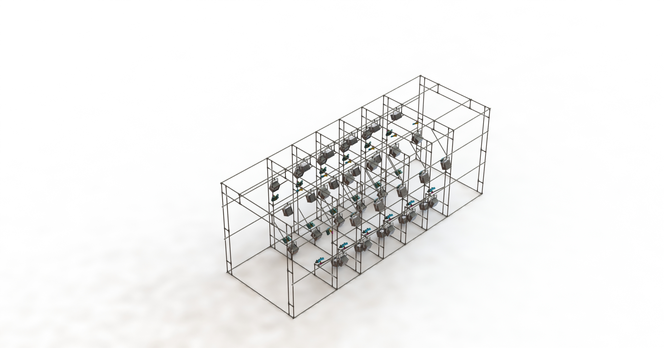

Developed by: Jason Brannick, Kevin Byrnes, Spencer Kirkham, Wenkun Liu, Alec Maccaro, Christian Mergl, Anuj Roy, and Armani Tagle

Completed: May 1, 2020

**Table of Contents**

**Mechanical Structure** **3**

Final CAD Renderings of Complete Tunnel - Alec 3

Cut Chart - Spencer 4

In-Progress Aspects of the Frame Construction - Armani/Spencer 5

Future Tasks in Frame Construction - Christian 7

Canvas Structure Mounting - Armani/Wenkun 7

Connection Throughout Tunnel Structure 8

Attachment to Cameras 10

Connection in Handling Areas 12

Handling Area - Alec 14

**Cameras** **17**

Recording Parameters - Anuj 17

Mount Assembly - Alec 17

Positioning in Frame - Alec 18

Recording Configurations - Kevin 21

Calibration/Point-Tracking - Kevin 23

**Lights** **27**

Positioning in Frame - Christian 27

Temperature and Brightness - Wenkun 28

Temperature Measurements 28

Brightness Testing 29

Future Testing Recommendations - Wenkun 32

**Electrical** **33**

Line Drivers for Camera Power and Triggering - Anuj 33

Camera Trigger Wiring and Connection Diagram- Christian 34

Dual BNC and Line Driver Power 34

Using Ethernet Cable to Substitute Three Cables 36

Data Transfer and Storage Options - Christian/Wenkun 36

Purchased Server ($3500) 36

Custom Built Server ($4000) 37

Data Transfer and Storage Topography - Christian 38

Monitors and Wiring - Jason 39

Display Solution 1A ($325) 39

Display Solution 1B ($169) 39

Display Solution 2A ($1,072) 39

Display Solution 2B ($580) 40

Light Configuration and Wiring - Christian/Armani 40

Cable Management - Anuj/Spencer 41

**Control Terminal - Christian** **43**

**Test and Operation - Christian** **44**

Light Testing 44

Camera Trigger Testing 44

Data Transfer Testing 44

Full Test Run 45

Point Tracking Testing 45

**Budget and Ordering** **46**

Previously Purchased - Spencer 46

Future Purchasing 47

End Section Materials 48

Data Transfer and Storage Equipment - Christian/Wenkun 48

Video Feed Display 49

Brunei Shipping Quotes 49

**Appendices** **50**

Brunei Shipping Quotes 50

Allison Shipping International Inc. Quote 50

A2 Global Shipping Quote 51

Chronos Ring Topography 52

Chronos Ring Topography Map 52

Chronos Ring Topography Description 53

**Contact Information** **54**

# 

# Mechanical Structure

## Final CAD Renderings of Complete Tunnel - Alec

The tunnel mechanical structure was designed to support the full load of 50 high speed cameras and 40 industrial filming lights. The structure is broken down into panels for ease of assembly and camera access. It consists of 1-inch outer diameter steel bars and steel pipe connectors from McMaster.com. The structure was designed and fully rendered in Solidworks, including cameras, lights, and all mounting hardware. The full model can be found in the Google Drive CAD folder and can be referenced for structure dimensions. Figures 1.1 and 1.2 show full CAD renderings of the complete structure.

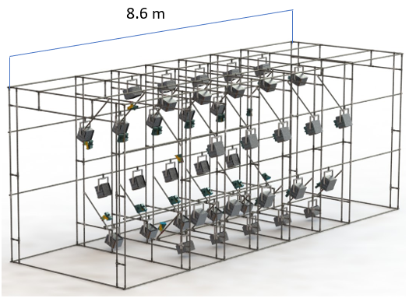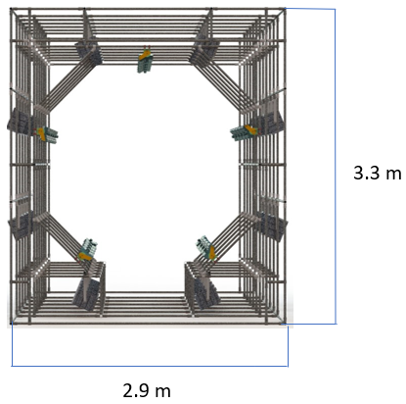

**Figure 1.1.** **Left** - Isometric view of tunnel. The full mechanical structure consists of steel tubes and connectors designed to support 50 high-speed cameras and 40 industrial lights. **Right** - Front perspective view looking into the tunnel. This highlights the octagonal panel shape and camera geometry.

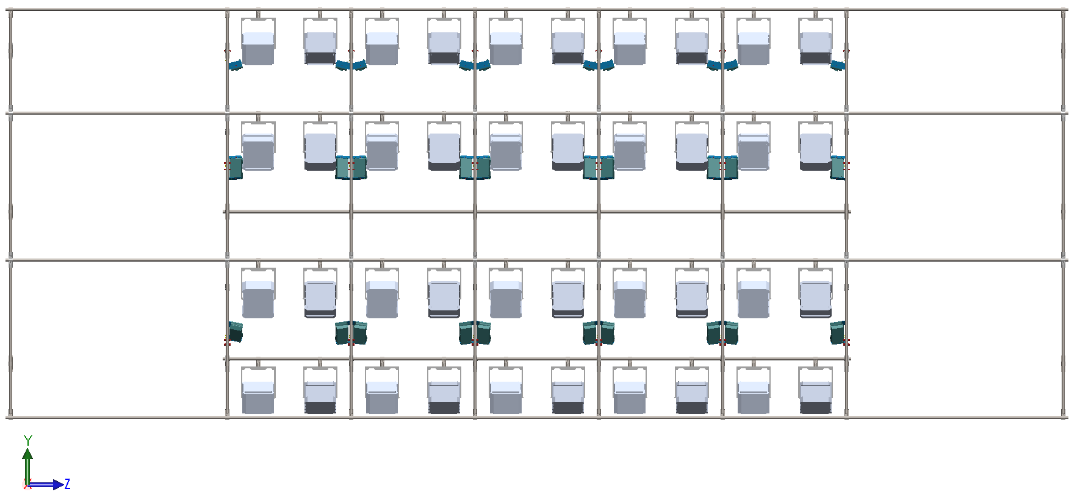

**Figure 1.2.** Side view of the tunnel. This shows the panel alignment and light distribution, as well as the end sections which will be used for animal handling. The structure is about 8 meters long and 3.2 meters tall.

## Cut Chart - Spencer

To minimize the amount of waste material within the structure, a cut chart was developed based around a single panel. Table 1.1 below shows relevant information to panel construction. The upper half of the table lays out the parts required to construct one panel. The “Quantity” column shows how many times each part in the corresponding “Parts” row can be cut from a single tube. For example, the first row shows that parts 28-16 and 28-10 can be cut a total of two times each from one 8-foot steel tube. The lower left portion of the table lists each part number with its respective length and quantity needed to construct one panel. The lower right portion of the table lays out how many bars should be used within each panel and throughout the whole structure. This table should be followed in order to build the structure panel by panel, and is vital in maximizing each 8-foot steel tube and minimizing material waste. As each part is cut, it is recommended that it be labeled and placed in the designated area on the floor by part number. The parts can then be used to construct each panel by following the 2D drawing shown in Figure 1.3.

**Table 1.1:** **Panel Construction Chart**

| **Cut Chart** | | | | |
| --- | --- | --- | --- | --- |
| QTY | Parts | | | |
| 2 | 28-16 | 28-10 |  |  |
| 2 | 28-09 | 28-03 |  |  |
| 2 | 28-04 | 28-05 | 28-07 |  |
| 1 | 28-15 | 28-06 | 28-06 |  |
| 2 | 28-14 | 28-13 | 28-11 |  |
| 2 | 28-01 | 28-02 | 28-02 | 28-02 |
| 28-08 | 28-08 | 28-12 | 28-12 |
| **Per Panel** | | | **Other Information** | |
| Qty Needed | Part No. | Length (cm) | Bars Per Panel | 11 |
| 2 | 28-01 | 86 |  |  |
| 6 | 28-02 | 11 | Panels  Needed | 8 |
| 6 | 28-02 | 11 |
| 2 | 28-03 | 115.5 |  |  |
| 2 | 28-04 | 110.5 | Bars Needed  *Panels Only* | 88 |
| 2 | 28-05 | 76.5 |
| 2 | 28-06 | 69 |  |  |
| 2 | 28-07 | 50.5 | Depth Bars  Needed | 84 |
| 4 | 28-08 | 26.5 |
| 2 | 28-09 | 122 |  |  |
| 2 | 28-10 | 116 | Total Bars  Needed | 172 |
| 2 | 28-11 | 68 |
| 4 | 28-12 | 31 |  | |
| 2 | 28-13 | 81 |
| 2 | 28-14 | 87 |
| 1 | 28-15 | 89.5 |
| 2 | 28-16 | 125 |

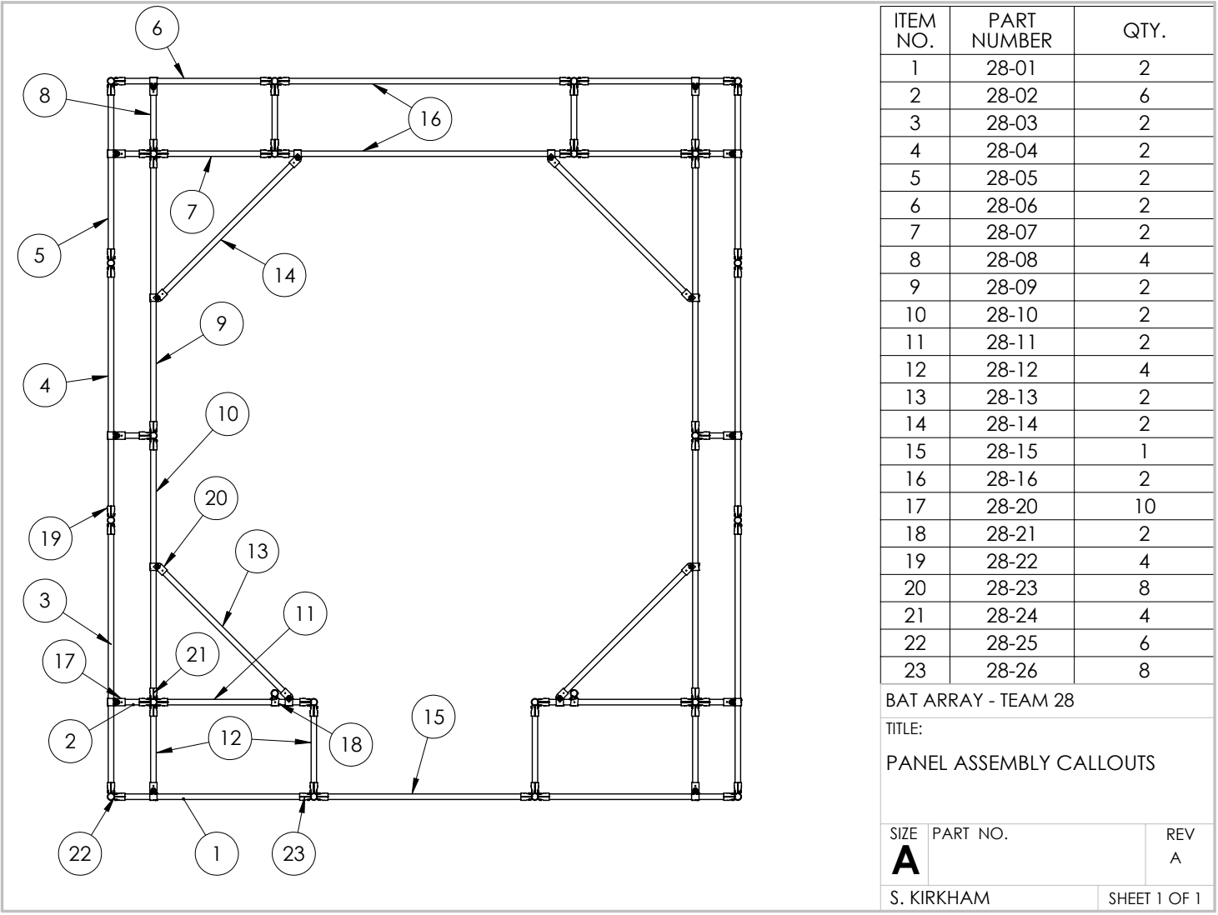

**Figure 1.3.** 2D drawing of a single panel with callouts for required parts and quantities. This must be used to ensure proper placement of the parts within the half-panel template.

## In-Progress Aspects of the Frame Construction - Armani/Spencer

The team started by creating a template of one half-panel, a small portion of which can be seen in Figure 1.4, made out of 23/32” plywood and 1” dowels. The dowels were secured to the plywood using screws, so that each respective connector based on the 2D drawing of the panel could be placed on there. The plywood template helps with creating similar length bars and ensures that all panels are uniformly produced. A complete half-panel can be seen in the left image of Figure 1.5 and a full panel in the right image. Overall, the process of creating one panel is estimated to take about 1 hour and 30 minutes. 30 minutes to cut all the bars of the panel based on the cut chart, and about one hour placing all the connectors on the dowels of the wooden template and the bars afterward.

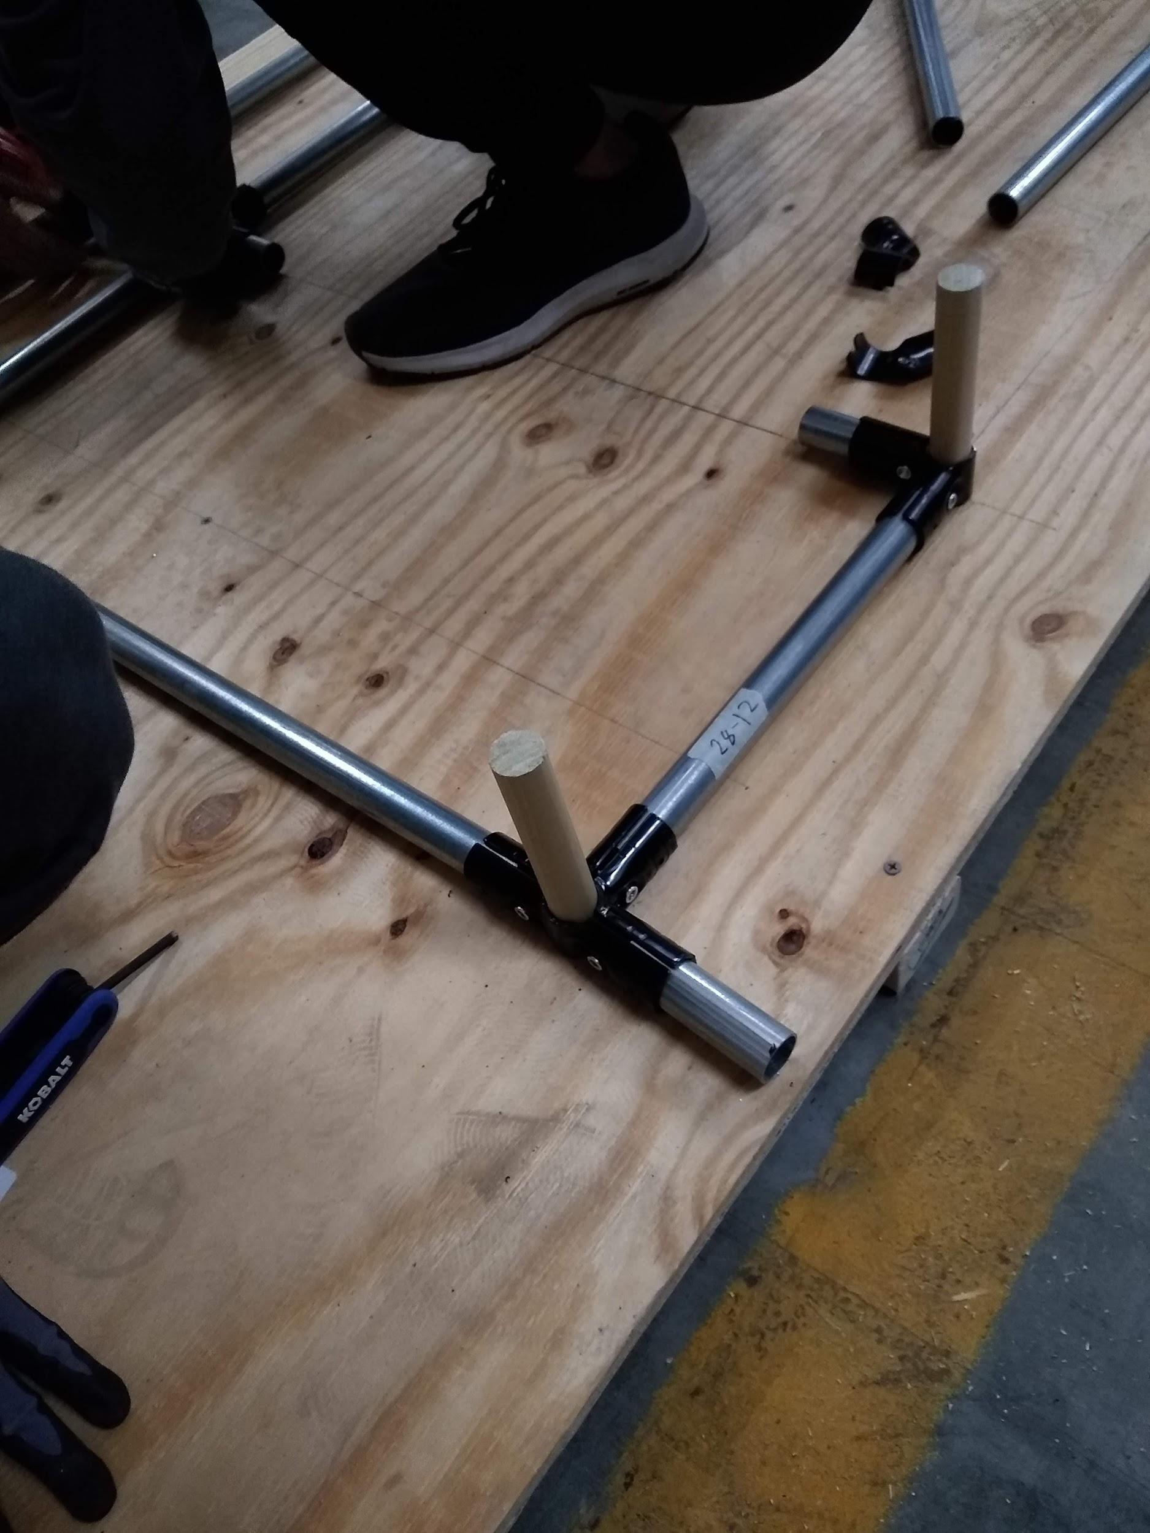

**Figure 1.4.** View of a portion of the wood template showing how the connectors slide on over the dowels and the steel tubes are inserted. Please note that a scrap portion of a tube should be used as a placeholder within the connector during assembly to ensure a proper fit between all parts.

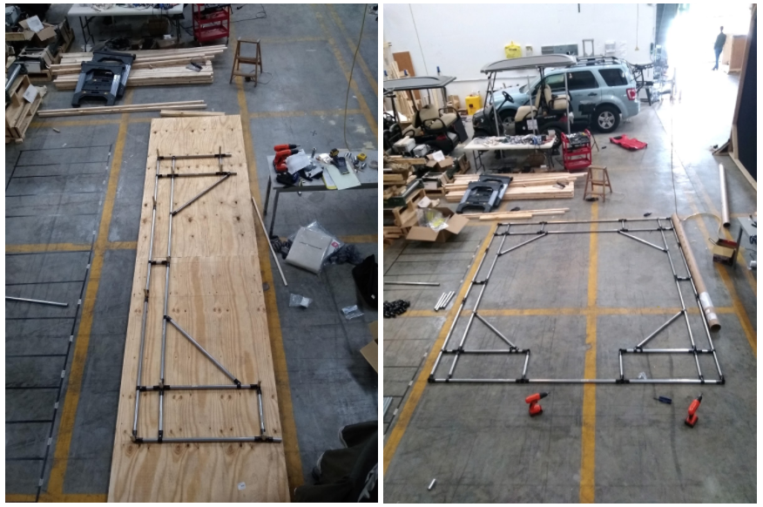

**Figure 1.5:** A complete half-panel on the plywood template is shown on the left. The right image shows a complete full panel. Both halves can be made using the template, but notice the three horizontal bars used to connect them. Please refer to the 2D drawing above and the cut chart in Section 1.2 for more information.

## Future Tasks in Frame Construction - Christian

At every connection in a single panel, drill through the pipe where the bracket hole is (shown in Figure 1.6). Put a bolt through the connector and bar and then tighten down a nut on the other side. This will serve as a reinforcement to the bracket and also ensure that the tube does not come disconnected in any other step of construction or operation.



**Figure 1.6.** McMaster T-Connector. The T-connectors (and all other connectors) have a hole drilled into the side of them at the base. This hole can be used to insert a bolt for additional joint security.

Once each panel is complete, they need to be connected together. Every bar that runs lengthwise through the structure will need to be lengthened. At the end of each bar that needs to be extended, thread the pipe end and attach a threaded 1” coupler. Thread another pipe and connect it to the opposite end of the coupler. Now, two 8-foot bars form a rigid 16-foot bar. Most bars go through the entire length of the structure and will need to be ~28 feet, or three-and-a-half bars connected together. Any excess can be simply cut off at each end of the structure.

Poles that run the length of the structure will provide stability and mounting locations for the lights. Each light should be hung using a T-connector over the bar with the open-end slotting over the light bracket “dowel”. Drill through the “dowel” on the light bracket so that a bolt can be run through each T-connecter onto the bracket. This will ensure that the light does not fall through the connector/the connector does not separate from the bar.

## Canvas Structure Mounting - Armani/Wenkun

The purpose of the canvas to be installed on the tunnel is to provide a neutral and uniform background when recording the bats. Another requirement is to keep the walkway open, so that whoever needs to do maintenance would still be able to do so. So far this portion of the project is not complete. A white 33’ by 44~45” cotton polyester broadcloth was ordered to be used as the canvas for the tunnel. The team conducted tests to choose the best material for the canvas, and the results of the experiment can be found in *Section 3.2 - Temperature and Brightness*.

### Connection Throughout Tunnel Structure

Our team has discussed two ways to connect the canvas to the structure. As mentioned before, in order to create a uniform background for our camera recordings, the walkway should also be covered with the canvas.

As shown in Figure 1.7, the first installation method will create a cross section with a shape closer to that of a circle. However, in order to cover the walkway, this cylindrical shape will no longer be viable. This should not affect the function of the tunnel at all. For the walkway, there will be tie-down points along the pipes to ensure the position of the canvas. As for the circular/cylindrical portion, use fishing line or a similar product to attach the canvas to the structure since fishing wires are generally quite strong and durable.

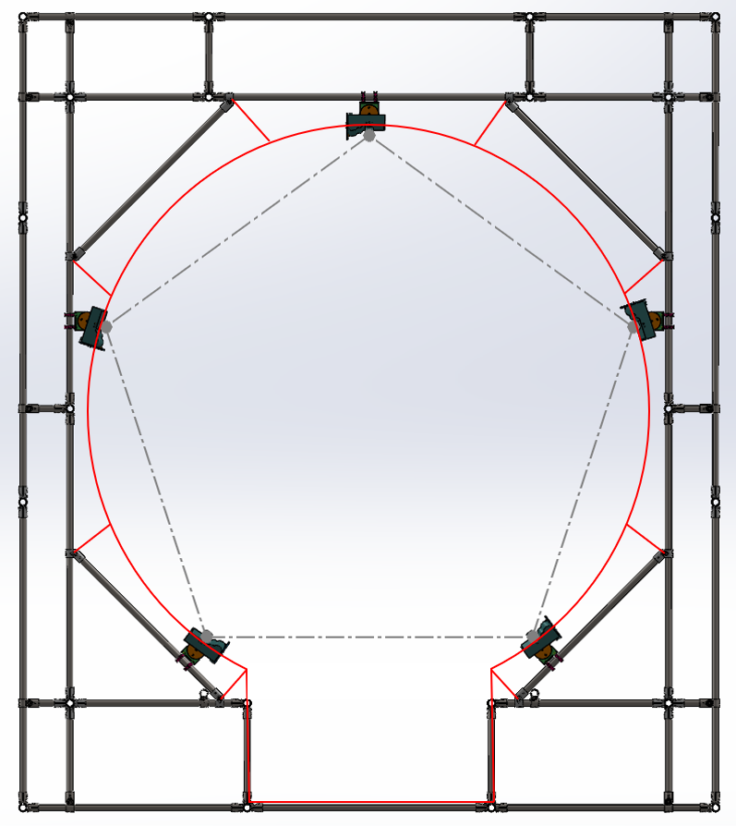

**Figure 1.7.** Cross-sectional view of the circular canvas installment, attached using fishing wire. This requires eight connection points at each panel.

The second design shown in Figure 1.8 is similar to our first design. However, rather than trying to create a circular cross section, try to attach the canvas directly to the structure. This could theoretically provide better rigidity of the connection. Both designs will require sewing work and fishing wires. Compared to the circular shape in the first design, the second design should require more sewing work. As mentioned before, we believe the reduced use and length of the fishing wire should give us a more well-attached canvas.

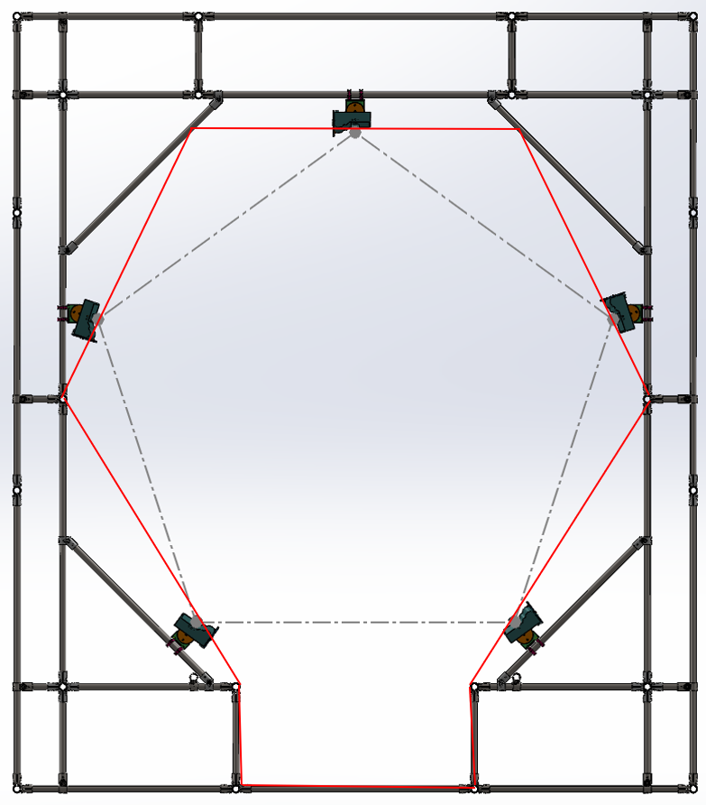

**Figure 1.8.** Cross-sectional view of the polygon canvas installment with direct structural connections. This method utilizes straight-line segments for easier installation and has just six connection points.

To summarize, since a portion of the canvas from the first design will be hanging from the structure, the circular shape for the top part might be more difficult to achieve. As a result, both designs will not achieve a perfect background for the cameras. However, since the color of the background will be kept uniform, these non-uniform shapes should not affect recordings of the cameras and the footage should not be affected. Overall, the second design should preserve a more rigid shape due to the polygon shape and direct connections to the structure. The team will recommend the second design moving forward.

### Attachment to Cameras

Since the canvas that we are using is not transparent, we need to cut out holes for the camera lenses. The first idea shown in the top of Figure 1.9 requires magnetic rings attached to the camera lenses. At the same time, cut out similar-sized holes on the canvas with corresponding magnetic rings. This connection method should provide us with the best view for the cameras since canvas is modified to fit exactly the camera lenses. However, if someone moves the canvas by accident or significant vibrations are transferred to the structure, the magnetic rings might become detached. In this case, the camera positions will have to be recalibrated. However, this situation is highly unlikely since the cameras and the camera mounts are fixed well to the structure itself.

The second method shown in the bottom of Figure 1.9 will also require cutting holes on the canvas. For this design, cut rectangular cut-outs on the canvas to provide view for the cameras. Since the cameras have different horizontal and vertical viewable angles, rectangular cut-outs seem more reasonable than circular ones. Additionally, they make modifications on the canvas easier and this design will not risk changing the camera positions as discussed in the first design. One potential drawback is that the cut-out may create non-uniform areas for the white canvas background. If the bat in the tunnel happens to fly over these areas, the recordings will not be uniform compared to recordings elsewhere.

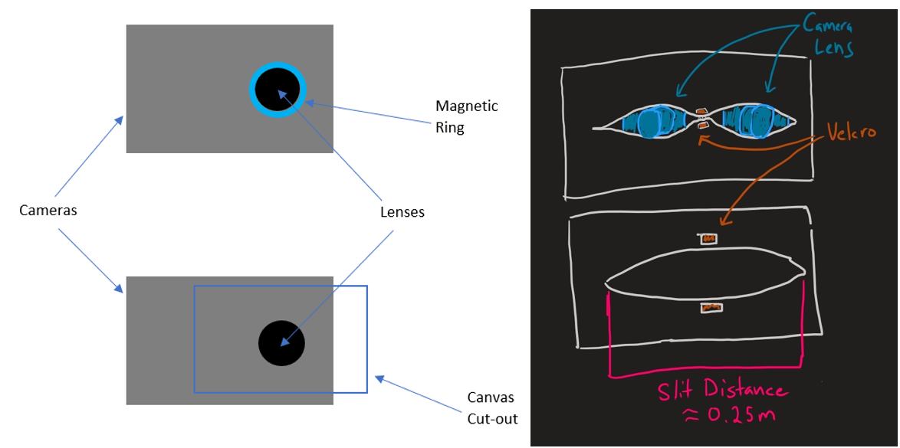

**Figure 1.9.** **Left -** Diagram showing both the magnetic ring and canvas cut-out attachment methods. The upper image details a smaller cut-out around the lens versus the larger cut-out in the bottom image. **Right -** Sketch of proposed camera attachment to canvas using velcro. Slits would be cut in the canvas and then secured around the camera lenses using the velcro.

To address potential issues associated with the two methods above, the team has decided that cutting a slit on the canvas and attaching velcro to it appears to be the best solution to the problem. Compared to the bottom design shown in Figure 1.9, the cut-out area is reduced. Thus, a more uniform recording background can be achieved. Additionally, compared to the first design, this alleviates the unnecessary stress off the cameras. Thus, the team recommends the cut-out design shown in Figure 1.10. Expanding upon this idea, velcro can be used to secure the canvas around the camera lenses as shown in Figure 1.11.

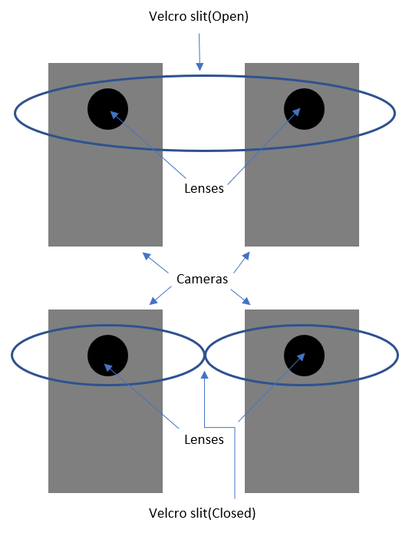

**Figure 1.10.** Diagram showing the velcro canvas cut-out attachment method. This design is the most balanced out of the three and it originates from the previous designs. The top image shows a single pair of cameras with the canvas cut around them. This cut should just be a slit so that it can be rejoined around the cameras, as shown in the bottom image.

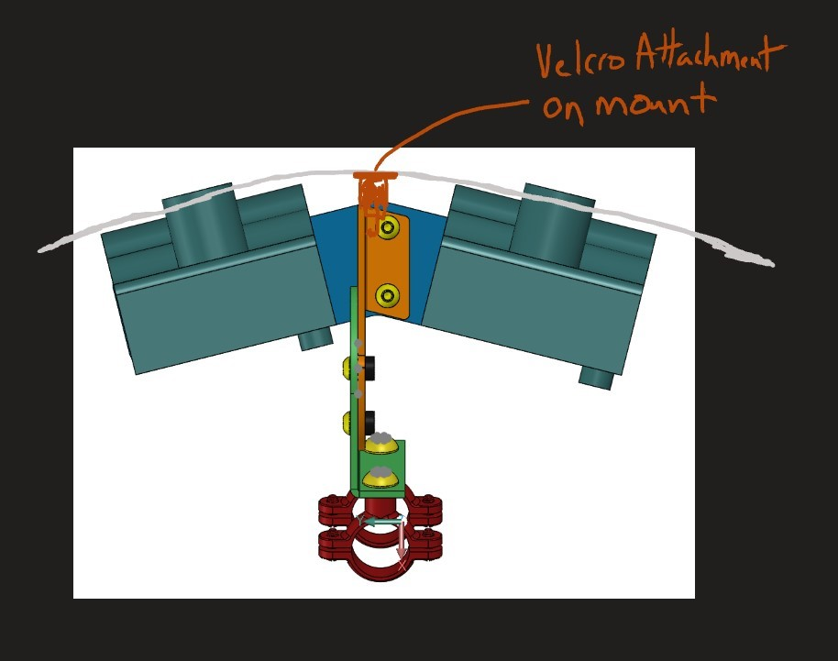

**Figure 1.11.** Top-down view showing the velcro connection method around the camera lenses. Velcro is used to attach the canvas to each camera mount throughout the array. Additional velcro or string should be used to pull the canvas taught around the camera mount. Otherwise, the camera lenses could fall back through the canvas.

### Connection in Handling Areas

As shown in Figure 1.12, the team has decided to create funnel-shaped end sections. This design aims to assist putting the bats inside the recording area as well as setting up workbenches and necessary equipment outside the center tunnel. Since the tunnel gets smaller from the entrance to the center of the tunnel, we believe that this should have an impact on the bats and should guide them inside the center of the tunnel. Additionally, the bigger sections at the two ends should provide more space for people to work inside the tunnel. Similar to the canvas installation discussed earlier, sewing work and fishing wires will be required to attach the canvas to the two end sections in this particular fashion. A rendered version of this concept can be seen in Figure 1.13.

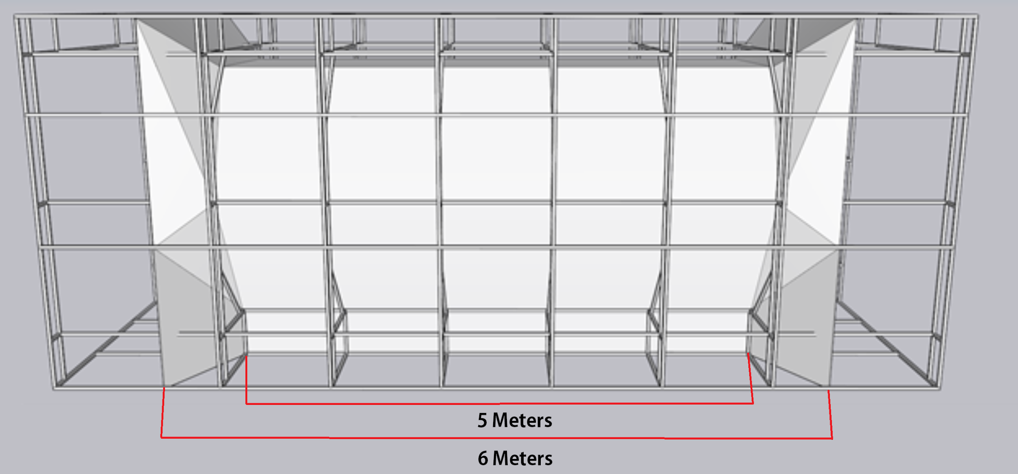

**Figure 1.12.** Side view illustration of the canvas flare in handling areas. To prevent the bats from flying into the structure, the canvas should flare out from the inner six panels. The canvas will be attached to the outsides of the frame to seal the tunnel. Sections that pass through structure beams will be cut and “wrap” around the structure and reconnect with the attachment of choice after prototyping.

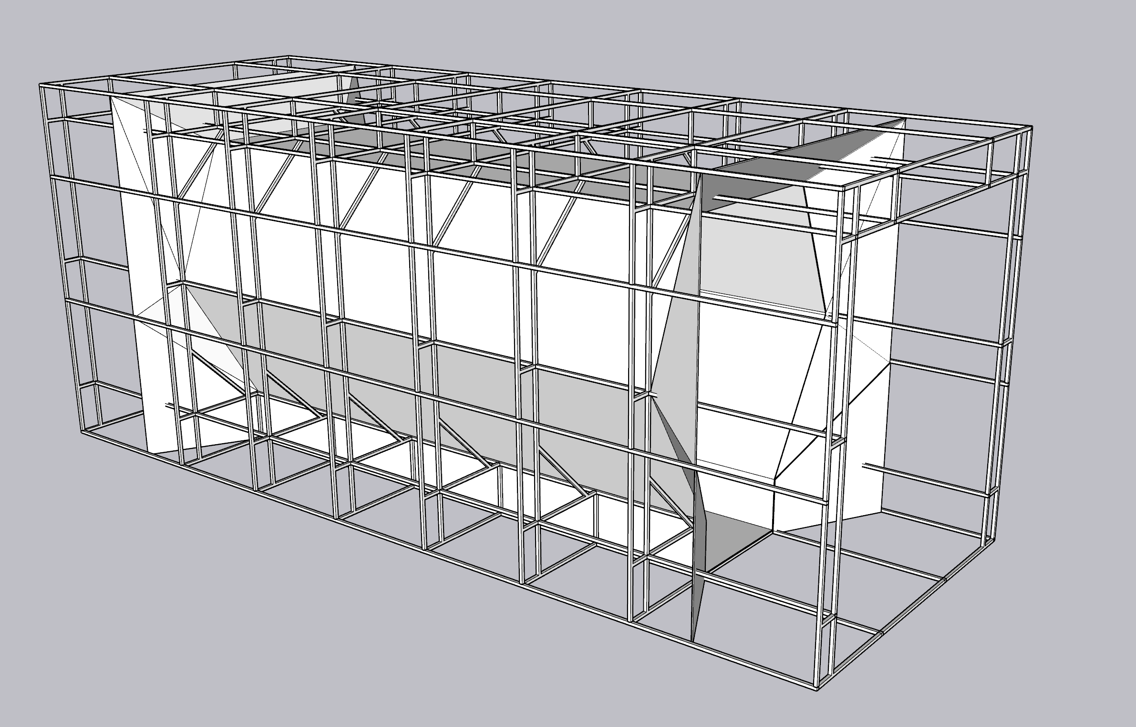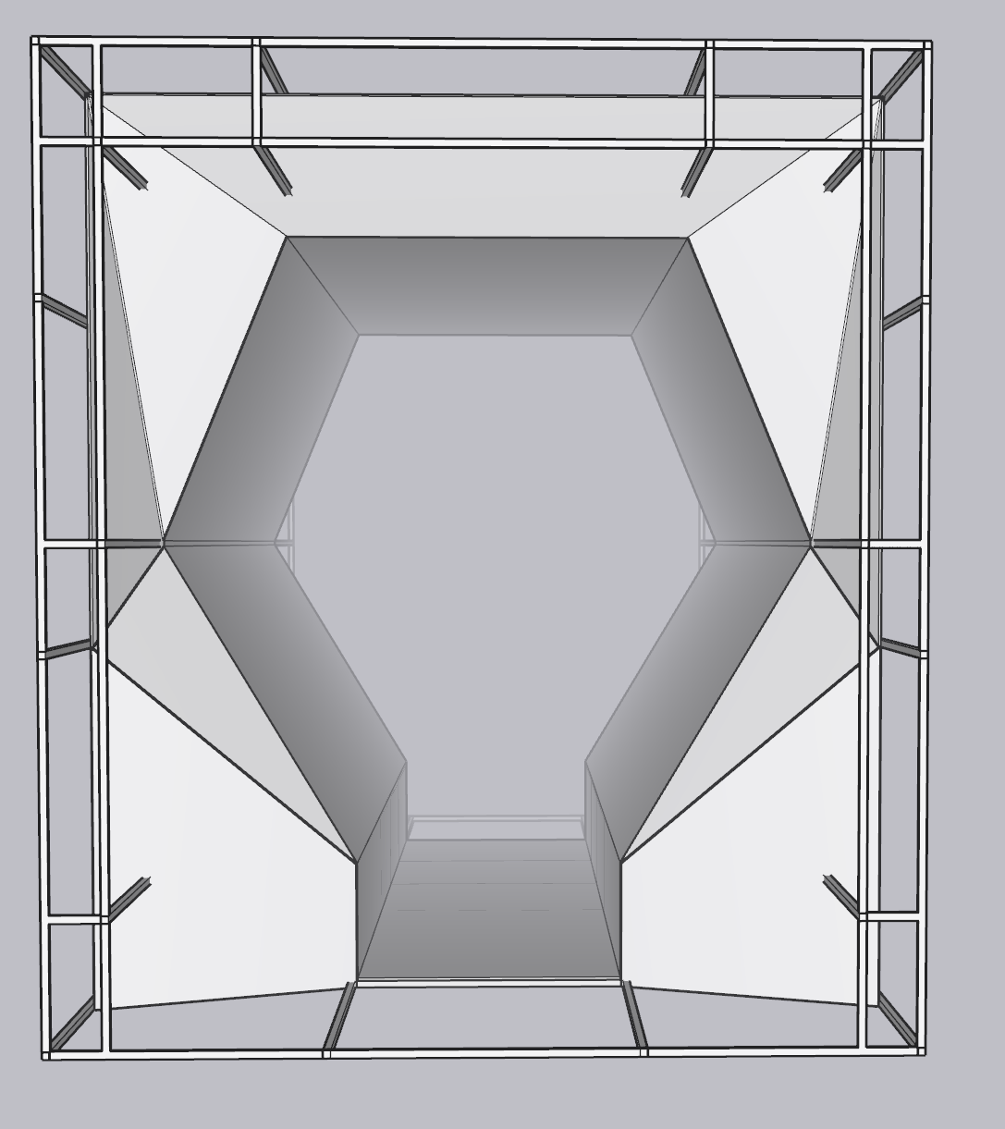

**Figure 1.13.** Rendering of Canvas in Solidworks. **Right** - Isometric view of structure with canvas attached. The canvas extends 0.5 meters into the end sections on each side. **Left** - End view of the structure where canvas flares. Use twine to guide canvas flare and wrap in canvas. This process may require small triangular panels to be cut and attached individually.

This model shows where the cameras would stick through and how the canvas would extrude outward towards the interior of the end section. The canvas would meet up with the material chosen for the end section creating an entirely enclosed area. Again, it is important to note that everything in this canvas installment section is UNTESTED. Pros and cons have been discussed in the section and recommendations are made throughout the segment. However, make sure to validate the designs that you choose to go with.

## Handling Area - Alec

The end sections of the tunnel will be a fully enclosed space where the operator can enter with the animal. The team has discussed several possibilities regarding the enclosure to ensure the animals cannot escape and allow for easy access. This part of the tunnel build is still in the prototyping phase currently with only the following ideas and sketches. We have yet to purchase material for testing of this part of the tunnel build and it will require hands on testing and interpretation of our sketches. Our ideas narrowed down to a heavy duty netting mesh surrounding each wall of the section with a magnetic mesh door entrance on the far ends, shown in Figure 1.14. This would allow for easy air circulation, animal containment, and visibility to the test/film team during tunnel operation. The suggested materials can be seen in Appendix 3 labeled “End Section Materials and Links”. An example of the magnetic self-closing mesh can be found in Figure 1.15.

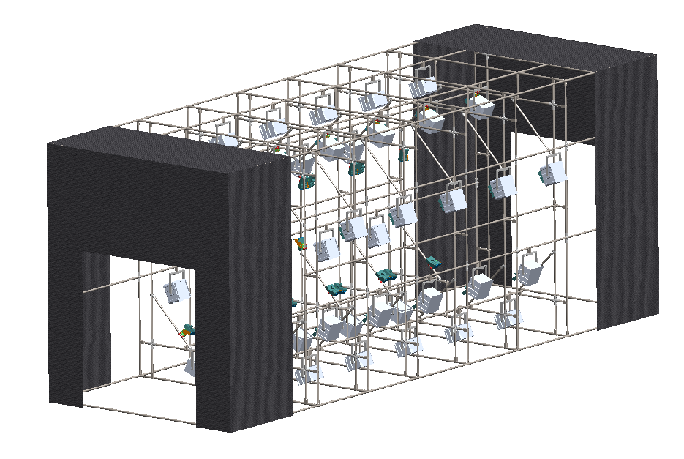

**Figure 1.14.** SolidWorks rendering of the structure showing the end sections made of netting. The sections will have magnetic doors in the negative space seen on the ends. The other surface edges will attach to the film canvas shown in the renders in the previous section.

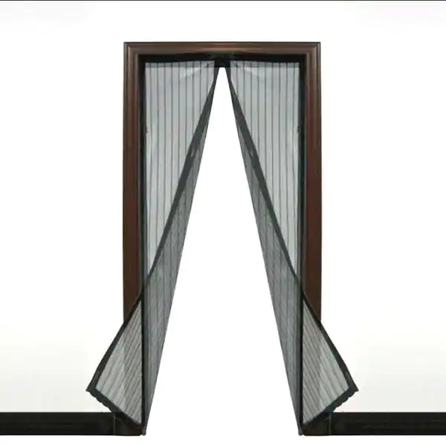

**Figure 1.15.** Example of a mesh screen that can be used to enter and exit the handling areas. This would be attached to the structure and restrict the animals’ flight within the recording area. Magnet sets on each panel make them automatically close when unobstructed.

In order to achieve this enclosure the team has come up with the flat pattern in Figure 1.16 for the netting that will enclose the end section and connect to the magnetic door as well as the filming canvas. The different panels will be cut out of the purchased material and attached to each other, the structure, and the filming canvas.

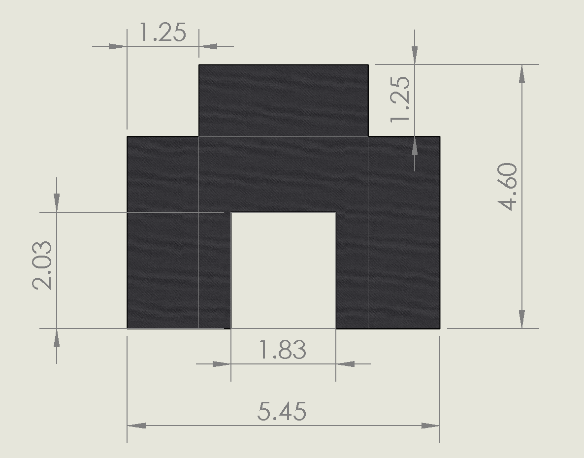

**Figure 1.16.** Flat Pattern of end section netting, separating the material into sections can be done during prototyping since purchased material can not be big enough for this entire pattern. The thin grey lines show where the canvas would fold. Dimensions are in meters.

Method of attachment should be determined by ordering a small section of the material for testing. The two following suggested methods should be tested on both the netting and filming canvas. The first method to be tested is to install grommets. Attaching grommets to the netting as well as the Filming canvas will allow for a monofilament or paracord to wrap through the holes for attachment. The second method to test would be an iron on velcro and opposing velcro strips will be ironed onto the edges of the material. Grommets are less expensive than velcro which should weigh into the attachment decision when prototyping. At the bottom sections where the canvas will attach to the poles velcro can be attached in two locations allowing the fabric to be wrapped around the poles and attach to itself on the back side. With grommets the chosen chord can be wrapped around the poles through the holes in the material creating a seal.

As shown in the previous section the film canvas will extrude to the outer frame of the end section. Once a method is chosen for attachment the two different materials can be attached creating a sealed tunnel/room.

The magnetic doorway already comes with velcro attached to its parameter, so the opposing hook or loop can be sewn or ironed onto the front netting material to allow for the door to attach and seal the end section. There is a possibility that more support will be necessary surrounding the door frame. Prototyping this design may require additional metal frame bars and connectors for creating a physical door frame.

# Cameras

## Recording Parameters - Anuj

The cameras used in this project are the Chronos 1.4 cameras by Kron Technologies. These cameras are a 1.4 gigapixel-per-second handheld high-speed camera that can capture videos at the highest resolution and lowest framerate of 1280x1024 and 1057 frames per second (fps). The cameras are also capable of recording up to 38,500 fps at a lower resolution, but for the purpose of this project, a higher resolution with lower framerate is the ideal setting. The cameras have a 1.5-hour battery life but can be run indefinitely when plugged in using the AC adapter. The power input of each camera is 17-20 Volt, 40 Watt DC. A full list of specifications about the camera are provided on the team’s Google Drive.

## Mount Assembly - Alec

The team has designed a camera mount that will allow for easy movement and placement on the structure in the five different locations around each panel. The camera mount has three variations: a dual-camera setup which will support two cameras and be used for the interior panels of the tunnel, and two half-mounts which will support either the right or left camera in the pair on either end of the tunnel. The mount features a rotating hinge that is tightened by hand once positioned properly. These designs have been finalized and will require an updated quote from a supplier before ordering. Drawings of the parts can be found in the Google Drive CAD folder labeled CAD Drawings. The most recent quote and purchase request can be found in the Quotes folder. The Solidworks subassembly “28-AM011” references the Dual camera mount. The subassemblies “28-AM011L” and 28-AM011R” reference the left and right mounts. All of the hardware in the models are from McMaster-Carr, except for the pole ring attachments. The hardware and part numbers for these components can be found in the Bill of Materials (BOM) in the Drive. The custom parts and hardware for these subassemblies have not been ordered yet. If money allows, a potential prototype can be ordered with hardware to test out. The team did not plan on this based on our confidence in the simple design. The final camera renderings can be seen in Figure 2.1.

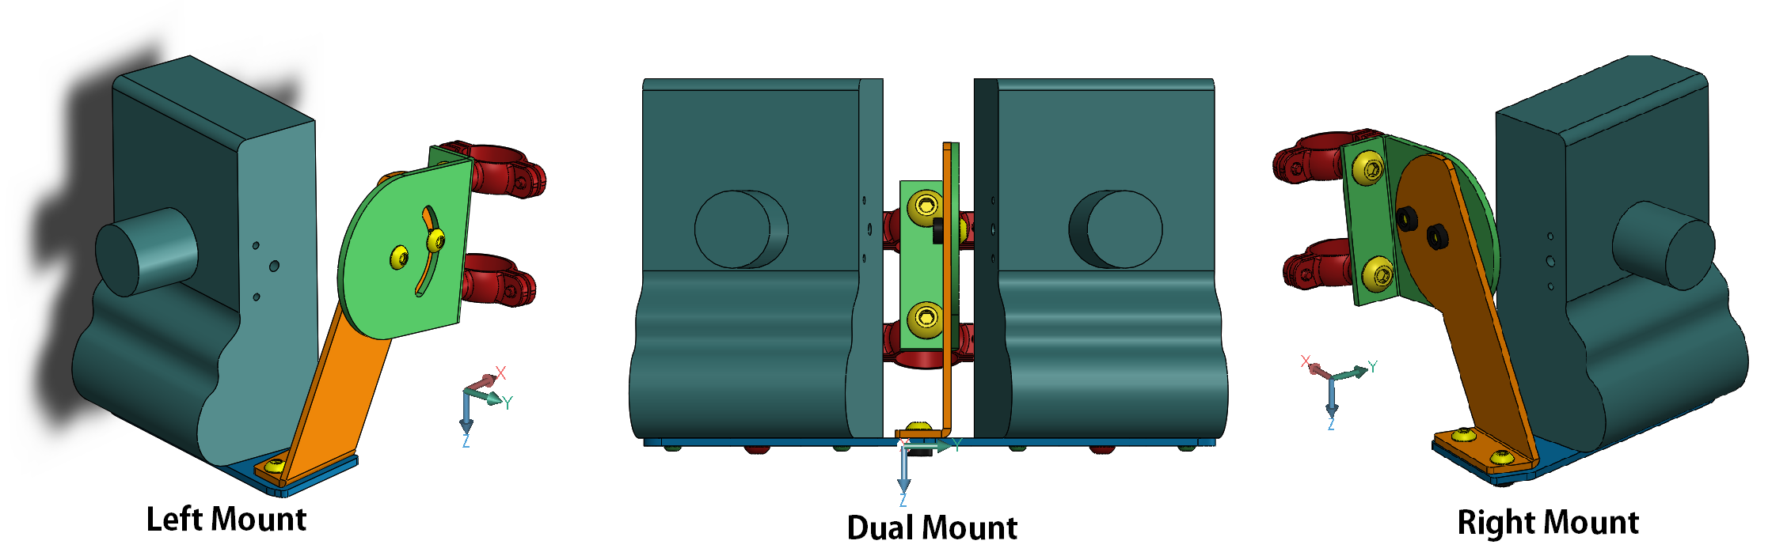

**Figure 2.1.** Final Renders of the Left, Dual, and Right Camera Mounts showing their overall design and final assembly. Once constructed, each camera mount will have a specified angle to be fixed to. These angles are further described in Figure 2.3 and 2.4.

The dual camera mount consists of the following custom and off-the-shelf components. Figure 2.2 shows an exploded view of the model with labeled components from Table 2.1. The figure is directly from the SolidWorks model and all parts are correctly labeled, positioned, and should be referenced when assembling. Everything bolts together with allen key tools. The pem nut inserts (Part 5) will require a small press found in one of the design labs or purchase of a pem press tool.

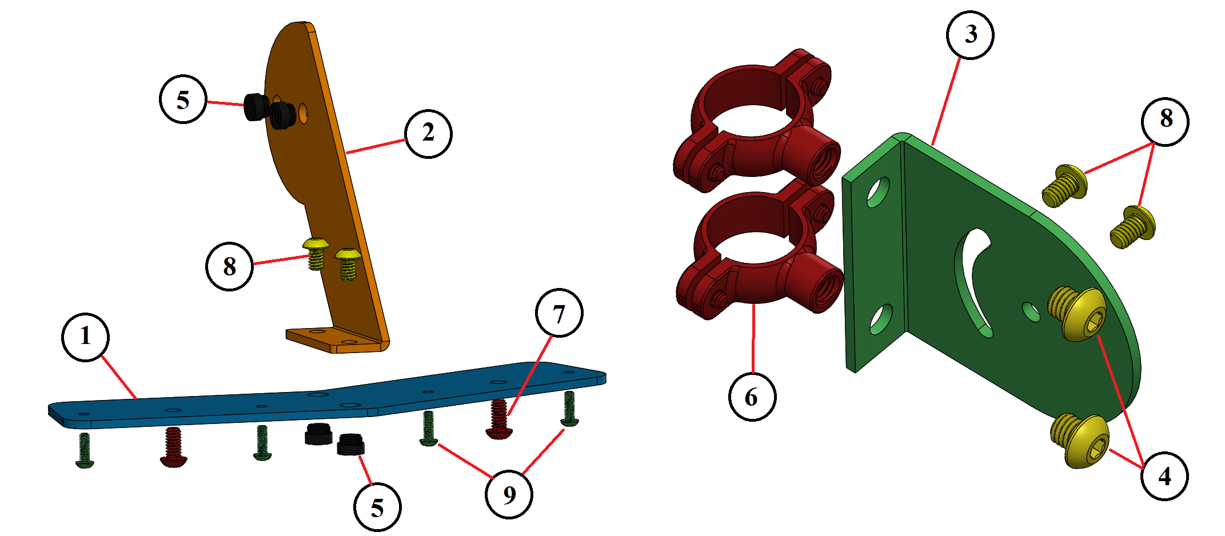

**Figure 2.2.** **Left -** Exploded view of dual-camera mounting plate with attachment plate. Parts are called out and should be assembled as shown. **Right -** Exploded view of angle selection plate and two mounting brackets. Bolts are shown in their intended insert locations. The split rings on the back of the mounting plate allow the camera mounts to be affixed to the piping that makes up the structure.

**Table 2.1: Part Reference Table for Figure 2.2**

| **Part Description** | **Reference Number** | **Part Number** |
| --- | --- | --- |
| Mounting Plate (PM01) | 1 | 28-PM01 |
| Angle Bracket (PM02) | 2 | 28-PM02 |
| Rotation Lock Bracket (M03) | 3 | 28-M03 |
| ⅜-16 Clamp Bolt | 4 | 91306A17 |
| Pem Inserts | 5 | 95185A205 |
| ¾ Split Ring Clamp | 6 | 302049 |
| ¼-20 X ½” Bolt | 7 | 92949A535 |
| ¼-20 X ⅜” Bolt | 8 | 92949A537 |
| M4 X 0.7 mm Bolt | 9 | 92095A192 |

## Positioning in Frame - Alec

The cameras are positioned in a pentagonal shape based on the team’s optimized design. The camera mounts allow for precise angle positioning once installed in the assembled panel. Shown in Figure 2.3, the cameras are positioned in five locations, each set to a different position. The cameras are mounted in a circular pattern where the attached plate side of Mount #2 is closest to the floor and the attached plate side of Mount #5 is furthest from the floor. This allows for consistency with pre- and post-recording data.

The camera mounts in the correct positions seen in Figure 2.3 should all create a symmetrical pentagon of approximately 1.36 meters lens center to lens center. In order to achieve this the camera mounts must be initially set to the specified values in the following diagram.

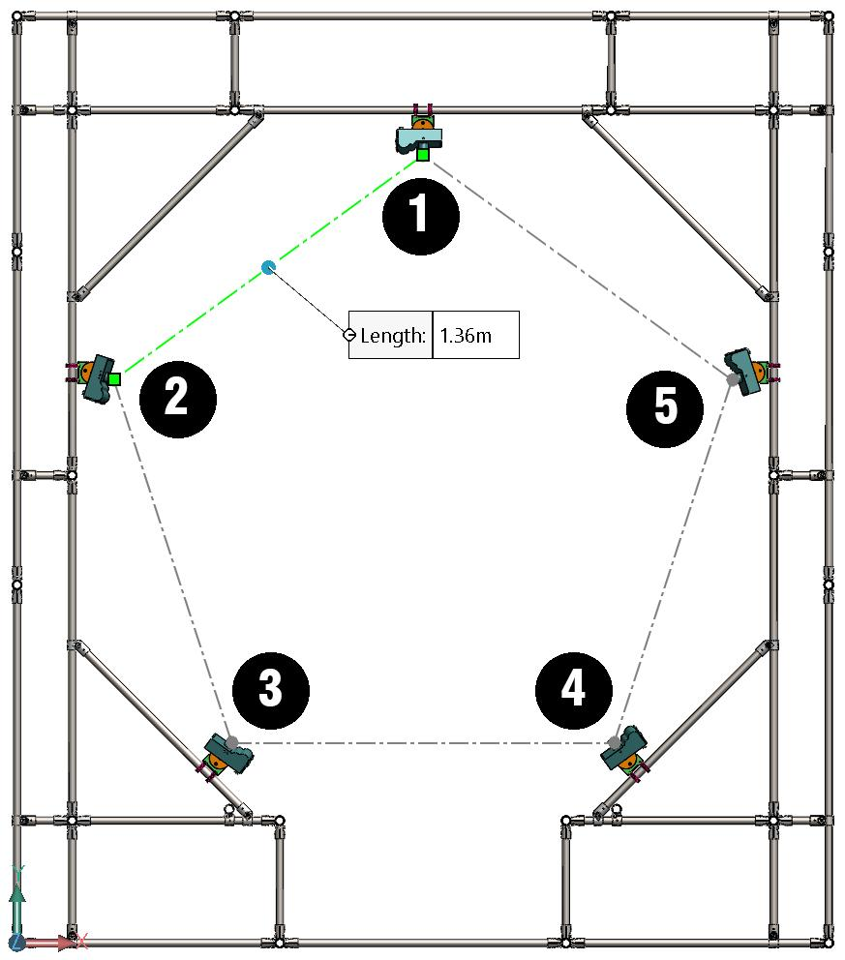

**Figure 2.3.** Cameras and mounts arranged in pairs around a single panel showing the pentagon geometry. The numbered positions are referenced in future figures for exact angle measure and placement.

Figure 2.4 shows the reference planes where the angles must be measured from. The center bolt can be attached loosely and the slot bolt can be hand tightened once the desired position is reached. Then both bolts can be tightened with hand tools. Once each mount is angled properly the camera on the opposite side of the rotating bolt heads may be installed first. This will allow for a lens to lens reference as well as ease of finer adjustments when attached to the panel. The mounts should then be attached to the panel in their corresponding positions. Each camera mount is attached to the pole using 2 piece hangers and must be tightened down after ensuring the camera mounts are parallel with the panel plane. The top camera mount attaches in the exact center of the top inner panel bar seen in Figure 2.3.

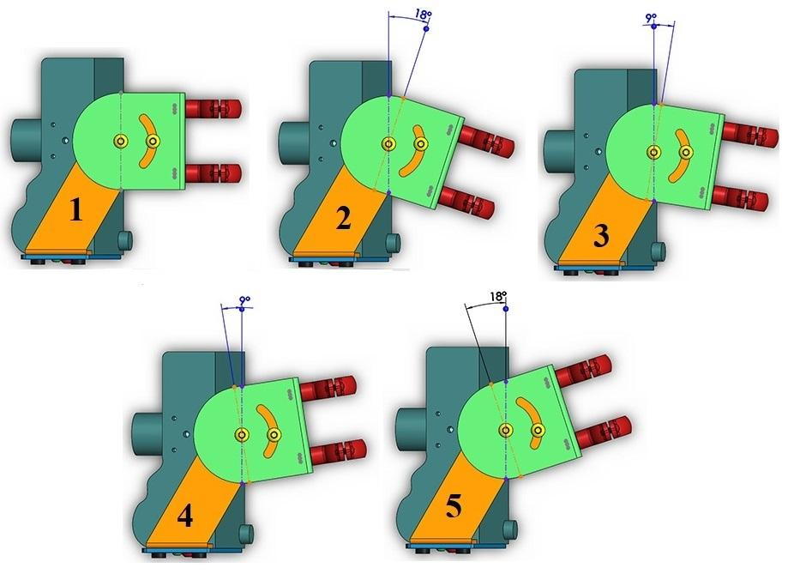

**Figure 2.4.** Camera mount angle positions for each of the five cameras for one panel. Each camera number corresponds to the number on Figure 3.3. Note that this view does not show the other camera in the pair (for dual mounts) or the other mount side. This is only an angle reference for the angle bracket and the angle lock bracket.

The second camera mount can be seen in the left image of Figure 2.5. The reference distance from the upper section of the panel coupling and the lower side of the camera mount hanger is 0.27 meters. This is the same for Camera mounts two and five. Also seen in Figure 2.5 is the position for camera mounts 3 and 4.

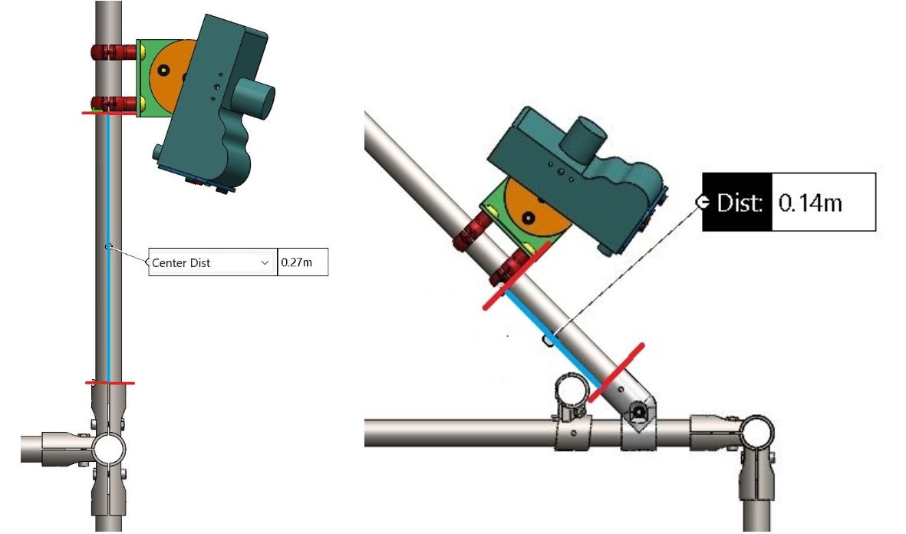

**Figure 2.5.** **Left -** Camera mount vertical reference position for panel assembly. The base of the angle lock bracket should be 0.27 meters above the top of the 5-way connector below it. This is helpful for positions 2 and 5. **Right -** Mounting positions for the cameras placed on the 45o cross members. The distances for each side of the panel can be mirrored. This is helpful for positions 3 and 4.

The positions described in this section are based off of our SolidWorks model and will not likely be exact to the real structure. These dimensions are a guideline and reference to creating the closest symmetric pentagon once each panel is assembled. Slight tweaks to the panels bars and couplings, camera mount positions and angles may have to be made to create a symmetric and consistent array.

## Recording Configurations - Kevin

These cameras work in a Master-Slave configuration. In other words: the first camera to detect motion of the bat will be considered the “Master” (Figure 3.6) and this will be the trigger for all other cameras in its jurisdiction. All other cameras with the exception of the final camera, will be in the “Slave” (Figure 2.7). The final camera in the sequence will be called the “end-slave” (Figure 2.8), when this camera stops detecting motion, it will signal to the other three cameras that the bat has left their readable range and all four cameras will stop recording. This master-slave configuration is helpful since it: a. minimizes the amount of unwanted footage recorded, which leads to a lower data download time, and b. creates an automated triggering system.

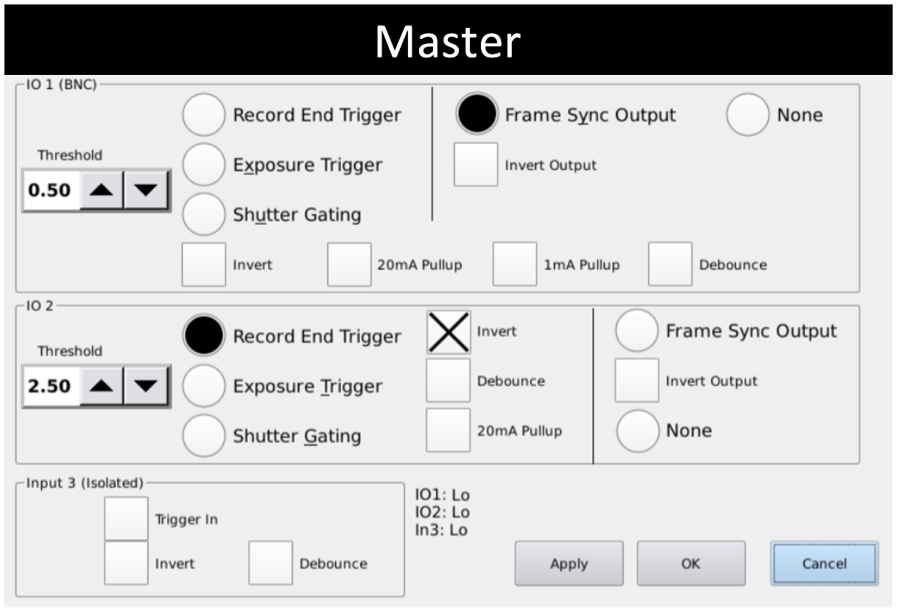

**Figure 2.6.** Master camera settings. In the configuration settings menu, match settings to these properties in order to set the desired camera to Master. The “Frame Sync Output,” “Record End Trigger,” and “Invert” buttons should all be selected.

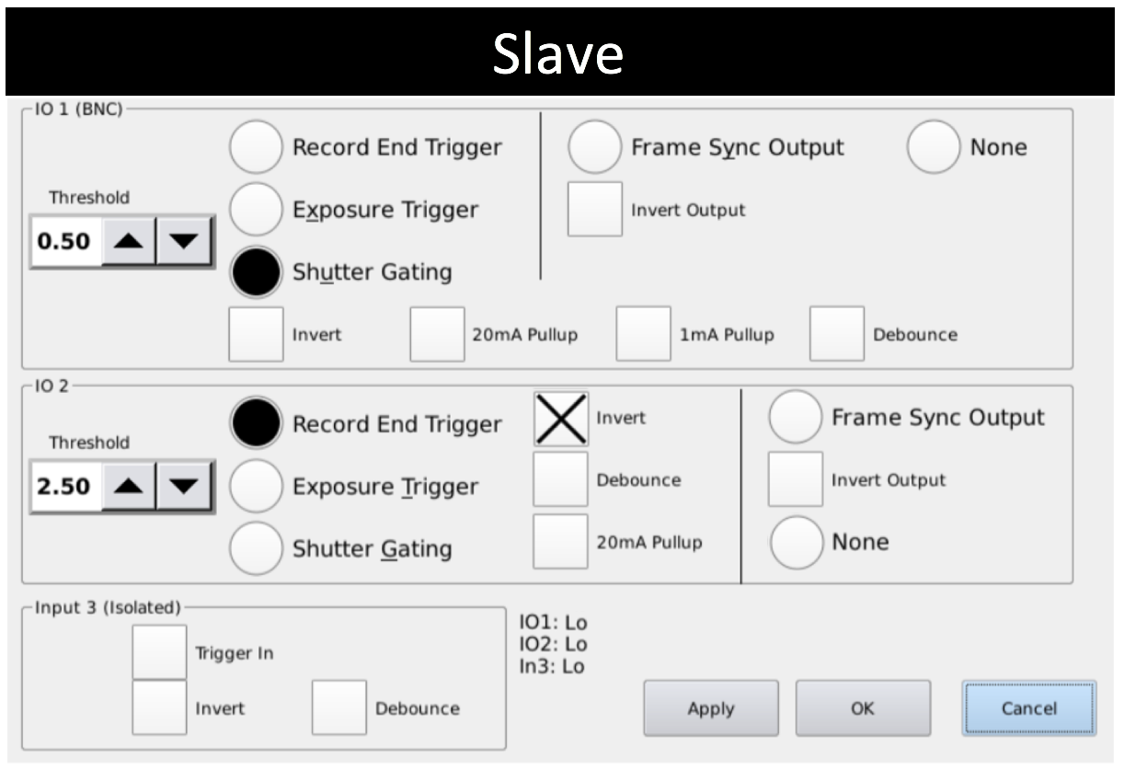

**Figure 2.7.** Slave camera settings. In the configuration settings menu, match settings to these properties in order to set the desired camera to Slave. Remember, this is for intermediate slave cameras, NOT the final camera. The “Shutter Gating,” “Record End Trigger,” and “Invert” should all be selected.

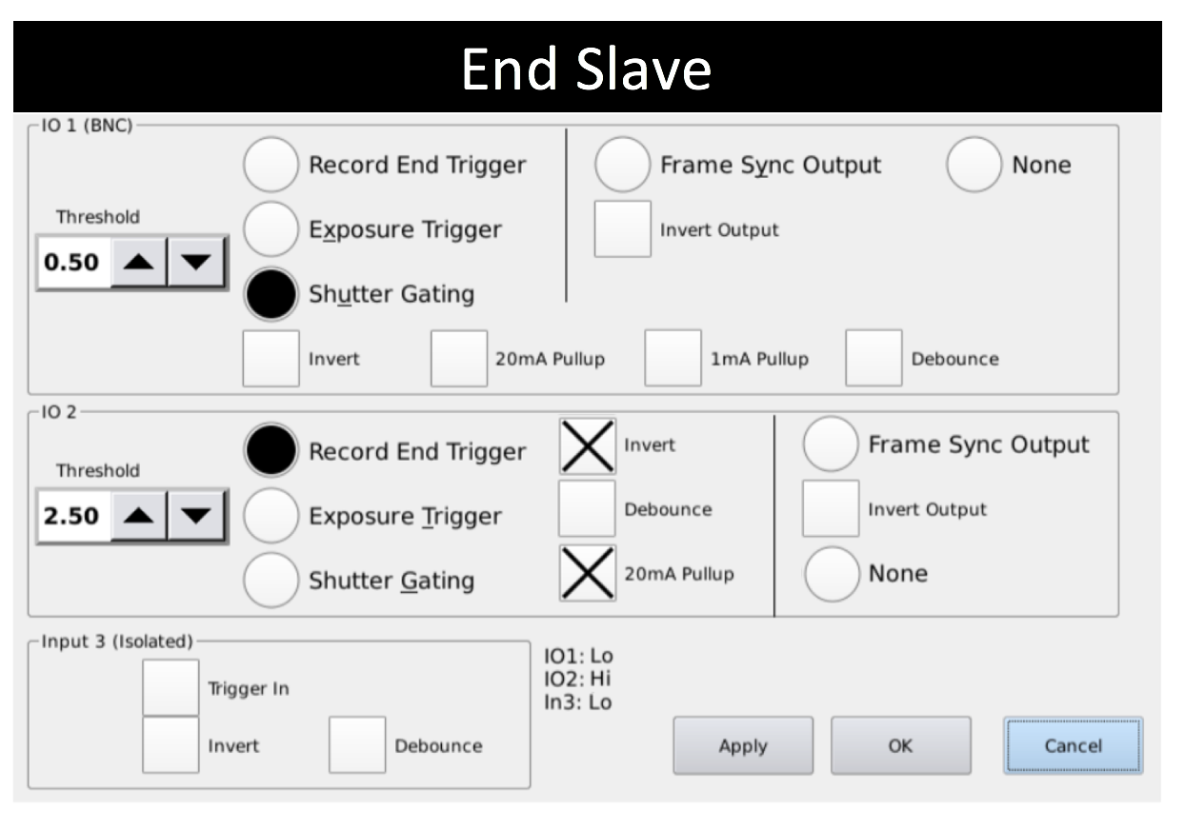

**Figure 2.8.** End slave camera settings. In the configuration settings menu, match settings to these properties in order to set desired camera to End Slave. Remember, this is the LAST camera in the sequence. The “Shutter Gating,” “Record End Trigger,” “20mA Pullup,” and “Invert” should all be selected.

Please refer to *Section* *4.2 - Camera Trigger Wiring and Connection Diagram* for information on how to wire the camera triggers together.

## Calibration/Point-Tracking - Kevin

In order to test the readable range of the program, we must replicate the conditions of the inside of the tunnel. This can be seen in Figure 2.9. The cameras are positioned side by side facing a white background to replicate the tunnel interior and eliminate any background noise. The bar in front of the cameras is marked every 10 cm. The bat wing is held at 70 cm and the camera focal point is set to that distance, which should provide a hypothetical readable range of 40-140 cm. The bat wing is then “flapped” at 10 cm intervals from 20 cm to 170 cm while the cameras record 997 frames at 1069 frames per second. A light with a diffusion shield of 80° was shone on the wing when it was being filmed. The data is processed using a MATLAB program which aims to track one or more point(s) on the wing simultaneously. Once you have collected your footage of the bat flying through the tunnel, upload the data for processing.

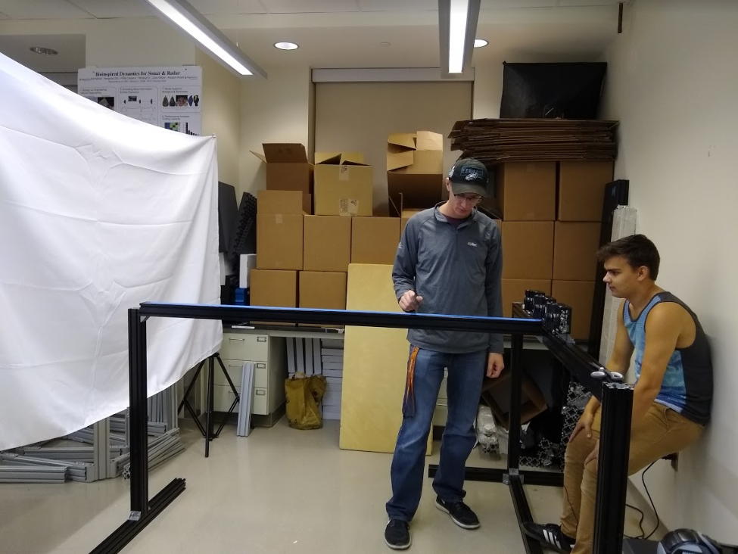

**Figure 2.9.** Physical setup of the point-tracking range experiment. This was made to simulate conditions of the tunnel interior and test the total range in which the cameras are able to track.

The program opens the control panel and the first frame of the selected video as shown in Figure 2.10. The user inputs the settings displayed and clicks on the point in the video that he/she wishes to track in the window on the right. The program will begin to automatically track that point. However, sometimes the program will lose the point it is tracking and stop recording. When this happens, the user will need to manually select the desired point again. This is referred to as “Number of Interventions”, and in small quantities is not dire. As a team, we decided that if three or more interventions were required, that distance would be “disqualified” and deemed unsuitable for tracking data. Additionally, the program sometimes “jumps” from tracking one point to tracking the point immediately beside it. When this happens, the program does not stop tracking that point, but since it is tracking the wrong point, this trial is disqualified.

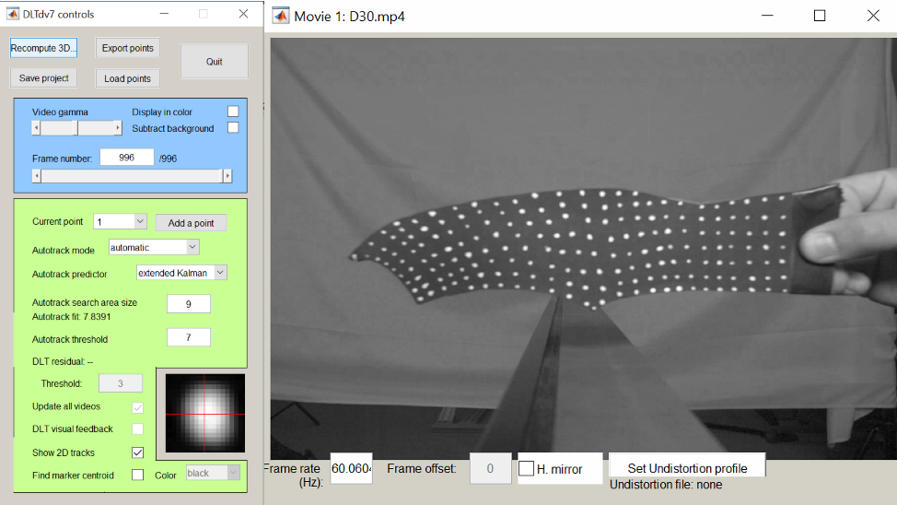

**Figure 2.10.** Tracker Control Panel within MATLAB alongside unprocessed 1st frame of 30 cm video data. It is important that you match the settings in your program to the setting presented on the left. This will ensure that the program is able to properly locate a dot with enough precision that it will not jump.

After processing each video twice with the methods described above, we have developed the following results:

**Table 2.2: Processing Results of Each Test Distance**

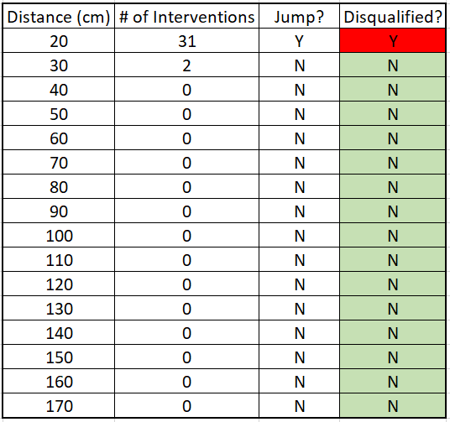

If the number of interventions exceeded three, or if the program jumped points (which only happened at the farthest distance), that distance was disqualified, meaning it is not considered readable range. As aforementioned, we predicted the readable range to be 40-140 cm, the results above conclude that the actual readable range is 30-160 cm, much better than we originally anticipated.

Below are representations of a failed test and a successful test. As shown in Figure 2.11 in the successful test on the left, the two points are tracked fluidly without interference. This is evident because both lines are continuous, follow similar paths, and do not jump any points. In the failed test on the right, one can see that the yellow line is not necessarily continuous. This means that during the first dot tested, the program jumped dots, disqualifying the distance immediately. **If your point tracking looks similar to the failed test (three interventions or one jump), that data is invalid and must be discarded.**

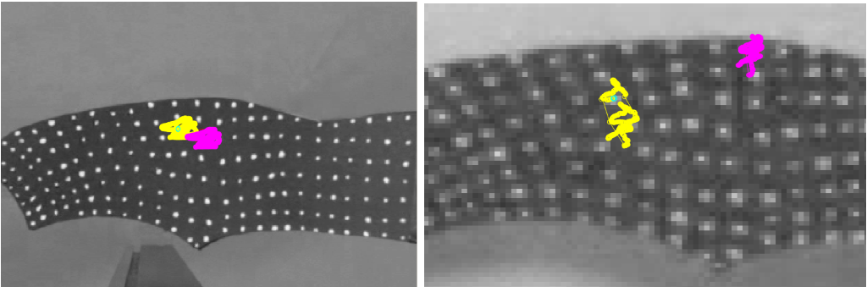

**Figure 2.11.** **Left -** 50 cm distance results, both points were tracked successfully; this is evident in how fluid and continuous the track lines are. **Right -** Failed test distance at 170 cm, the track lines show obvious discontinuities.

# Lights

## Positioning in Frame - Christian

The lights are positioned so that they provide even coverage for the area covered by the cameras. They are all positioned between the “panels” that hold the cameras. There are a total of six panels that have cameras on them, meaning there are five open spaces between them. With 40 total lights, eight will be between each pair of panels. This is shown in Figures 1.1. and 1.2.

Eight bars run through the entire length of the structure to hold the lights. To make the light distribution more even, the lights are in “phantom panels” in sets of four, alternating which bars are used. The graphic in Figure 3.1 demonstrates this principle. Each “phantom panel” will alternate A, B, A, B.

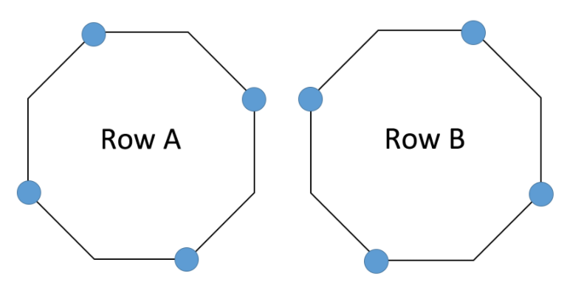

**Figure 3.1.** Using the eight light positions as vertices on an octagon, each “Phantom Panel” will have four cameras. They will alternate A, B, A, B, A, B, etc. This is shown in the full CAD renderings in Section 1.

To evenly space the “Phantom Panels,” each panel should be 50 cm apart, or 25 cm from the nearest panel. The graphic in Figure 3.2 demonstrates this for three camera panels (four phantom panels).

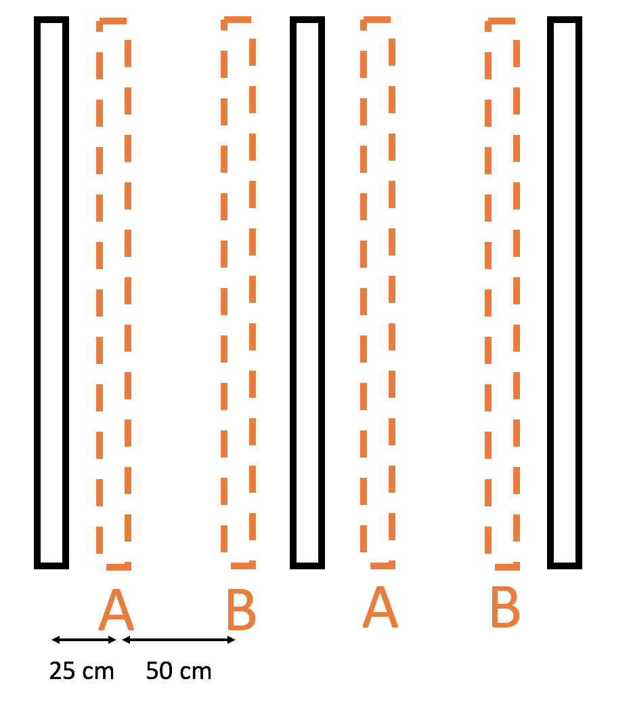

**Figure 3.2.** This is a side view of the tunnel. The black rectangles denote the camera rings and the orange dashed rectangles denote the “Phantom Panels” of lights, alternating A, B, A, B. Each “Phantom Panel” is 25 cm from the nearest camera panel and 50 cm from the next “Phantom Panel.”

It is important to note that this setup will require tweaking. This distribution is UNTESTED. It is highly recommended that, once at least the first 8 lights are installed (one A and B panel), this solution is tested. Use different diffusers to determine how to optimize light usage. The light only needs to cover the area between the cameras, any additional lighting is superfluous. If the light beam is too concentrated, use a larger angle diffuser and if the light beam is too wide, use a smaller angle diffuser. It is estimated that the 40o or 80o diffuser will be needed.

## Temperature and Brightness - Wenkun

### Temperature Measurements

After the concept generation process, the team performed further temperature testing for the tunnel structure. The simulated tunnel structure is made of 80/20 aluminum tracks and covered with a sheet of white cloth. Additionally, the top of the tunnel is also sealed to achieve a closed space. Since the tunnel should be closed during the recording of the animals inside, this approach can better represent the real-world situation for temperature measurements. Then, three lights were placed evenly around the tunnel and each light is 10 cm away from the surface of the tunnel.

The setup is shown in Figure 3.3 and the maximum ambient temperature only reaches 31oC inside the tunnel after 25 minutes. Additionally, the maximum surface temperature reaches 33oC. Based on our research, the bats are unable to regulate their body temperature when the ambient temperature reaches 40oC. According to the results of the experiment, shown in Figure 3.4, heat should not be a concern for the animals. However, the cooling concept should be kept in mind as the project progresses and a more complete structure of the tunnel is built.

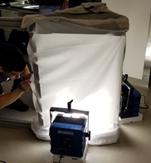

**Figure 3.3.** Temperature testing setup with three lights elevated at an inch off the ground. Test setup includes a three sided frame with lights on each side, and the ambient temperature sensor in the inside of the frame.

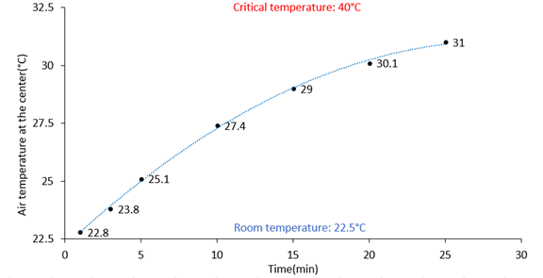

**Figure 3.4.** Temperature measurements with three lights at 100% brightness pointing directly to the center of the setup. A clear increase in air temperature can be seen with increased light exposure, before leveling off.

### Brightness Testing

Because of the high illuminance provided by the Nila Boxer lights, the team is concerned about the camera performance and the usability for the operator. Additionally, because of the relatively concentrated beam from the light, an even light distribution inside the tunnel should also be considered. Thus, the team conducted several brightness tests with the included 80o diffuser and several cloth materials.

The setup shown below is for testing without external cloth as a diffuser. The included 80-degree diffuser can be slotted right in front of the light and fixed in position. As a result, there will be no additional setup required for this test. Also, based on our geometry of the tunnel, the test was performed at distances between 0.5 m and 2 m. The graph of change in brightness with changing distances is shown below the setup. The brightness reduction as distance increases is relatively linear without the 80o diffuser. With the diffuser installed, the change in brightness is more abrupt for closer ranges. However, this nonlinearity is not as prominent at larger distances.

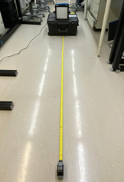

**Figure 3.5.** Elevated brightness testing setup without cloth to avoid reflections from the ground. For every 0.25 meter, the brightness was tested at a total of 2 meters.

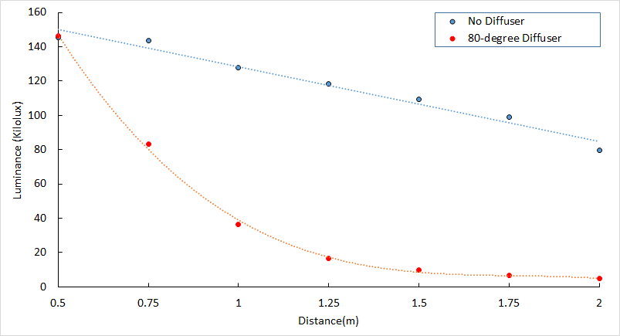

**Figure 3.6.** Single light testing results with and without the 80o Diffuser at 100% Brightness. Both of which were tested at increments of 0.25 meter for a total of 2 meters.

Additionally, similar tests were done on a thinner (silk) cloth and a thicker (nylon) cloth. In this setup, the sheet of cloth was fixed by two tripods in front of the light. One thing to note is that the light at the bottom is just to provide elevation for the other light so that the setup is consistent with the testing without cloth. Similarly, brightness tests were conducted at the same distances. We can see that despite the difference in thickness for the two types of cloth, the trend of brightness decay is very similar between the two. As a result, the team concluded that the permeability of light for different materials does not necessarily depend on thickness of materials.

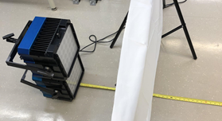

**Figure 3.7.** Elevated single light testing with cloth as the diffuser to avoid reflections from the ground. The distance between the light and the cloth is 0.5 meter.

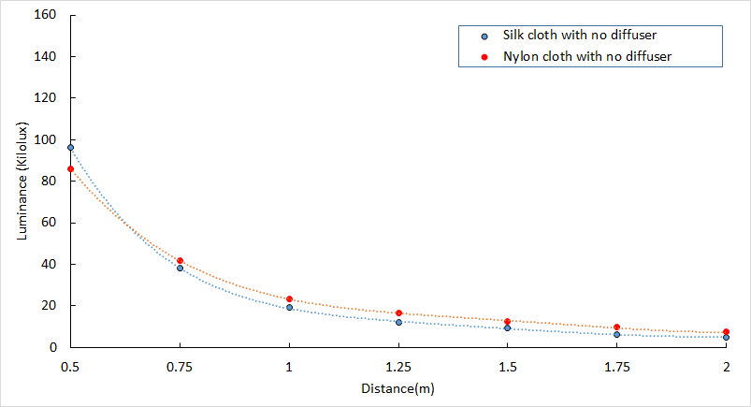

**Figure 3.8.** Single light testing results with silk and with nylon cloth at 100% brightness, showing both trends are the same as distance increased.

To summarize, because the lights do have dimming capability, we should choose a diffusing material that can let in the largest amount of light with a relatively linear brightness decay. However, we cannot decide on a final material for diffusing light since the team has originally planned to perform more tests with diffusers with varying diffusing angles and different canvas materials. Once a relatively accurate representation of the frame of the tunnel is built, more tests should be performed to assure an even distribution of light inside the tunnel. These tests together will determine the final canvas material for our design. At the same time, as mentioned before, temperature measurements should also be taken again inside the complete tunnel structure along with the canvas installed.

## Future Testing Recommendations - Wenkun

As mentioned in the previous section, both the temperature effects and lighting effects have been tested for the lights. However, those tests were conducted without the completed structure. With the limited equipment and setup, we have tried to create the best representation that we could in the earlier stages of the project.

The tests for the tunnel temperature show the worst-case scenario for a single section. However, without conducting tests in the actual completed tunnel, we cannot predict the effect of heat generation when all lights from different sections will affect the temperature distribution. Given the test results that have been gathered, the team does not expect there to be any problems associated with heat, however it is still recommended to test the temperature in the completed build. Details about the testing method will be included in the validation plans that correspond to our target specifications.

Similar to the temperature tests, the team has confirmed that the brightness of a single light is still plenty with the effect of a diffuser/cloth in front of the light. In the completed build, there will be a total of eight lights in a 1-m section. As a result, the brightness for the recording area should not be a concern. We would still recommend checking the brightness readings according to our validation plan since an even brightness distribution inside the recording area should be the goal. Even though the test results for a single light looks promising, more variables will be introduced while a total of 40 lights are involved in the final build. Since the lights positions and angles can be adjusted, make sure an ideal brightness distribution is achieved before fixing the lights to their corresponding positions. Finally, since the brightness can be adjusted for individual lights, using the included diffuser should yield the best light distribution as long as the brightness level is desired.

# Electrical

## Line Drivers for Camera Power and Triggering - Anuj

A more detailed detailing of wiring is described in the wiring section, but a brief rundown of the wiring for the triggering to be set up is as follows. First the BNC Cables are connected together with BNC connectors that connect a BNC from each camera in the array. These BNC cables can then be connected directly to the line driver. The line driver acts almost like another BNC connector and brings together all of the BNC connections to one unit. Several line driver board schematics were developed by a team who previously worked on the tunnel and those can be used as a reference for a future board to handle more cameras. These schematics can be found in the Google Drive under the Research folder, from there go to the Electronics folder which has the files for all provided schematics relating to the Line Driver. The schematics can be used to print out a working line driver that can then be used for testing. Our team’s plan was to print out one of these schematics and begin testing. We were unable to print a test board, so this remains UNTESTED for our tunnel. However, as a reference the line driver schematic that was referenced and scheduled to be tested is shown in Figure 4.1.

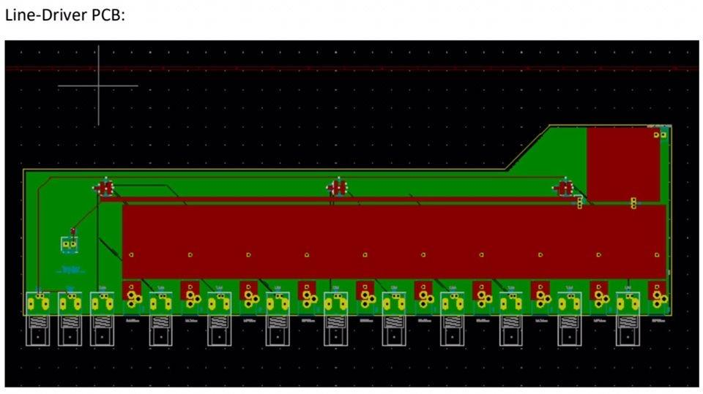

**Figure 4.1.** Line Driver PCB Board schematic that can be used as a reference for future Line Driver models with more ports than the twelve shown. This schematic can also be printed to perform testing on integrating the line driver into the design.

In the Line Driver, the bottom section with the clear segments are all of the locations where the ten BNC cables will be connected. In addition, the small red squares between the BNC ports are the triggering connection points. Here the triggering wires from the cameras will be connected to the ports along with the ground wires from the cameras that will also be connected to the red ports. The large red segment above the triggering and BNC ports contains amplifiers for the signals of all the ports to be connected to one central location. This one central wire can then connect to the server segment. In addition, the red segment houses an internal power unit so the whole board is powered.

Our team planned to develop a line driver with 10 ports to account for all the cameras in our section of the array. A full array would include five drivers with 10 ports each, so that all 50 of the cameras in the final design can be connected and powered within the array.

The line driver actually functions within the design by recording data using a shutter gating process. This process starts when the Master camera first sees an object then triggers and distributes a signal to the rest of the cameras. Shuttergating works through square waves, where when the square wave moves up the shutter of the camera opens and when the square wave goes down the shutter closes. This happens very quickly so there is no significant loss in frames. The distributed signal from the Master camera allows the rest of the cameras to also go through this data collection process which records the full data.

By having the line-driver outside of the structure we believe that the cabling of the entire structure is much more focused and allows for a more organized design. In addition our team had looked into possibly creating a powered line driver PCB board so that an external power source would not have to be used and so that the cameras could be supported with less cabling required. After all connections have been attached from the cameras to the line driver, the line driver is directly attached to the control terminal PC.

## Camera Trigger Wiring and Connection Diagram- Christian

### Dual BNC and Line Driver Power

Connecting the cameras together for synchronization, triggering, and data transfer requires the use of three connectors on the side of the camera, shown in Figure 4.2. Additionally, each camera will require its own power source: 17-20V 40W, as specified in the datasheet provided for the Kronos 1.4.

Trigger IO Port 1 is a BNC female connector. This port will be used for synchronization of the camera frames. In the application of the array, multiple meters of copper cable will produce delay times in the microseconds range. Given the fact that the desired recording specifications are between 1000 and 1500 frames per second, there is somewhere between ~650-959 microseconds between each frame. There will be plenty of time for the synchronization signal to pass between all of the cameras.

Trigger IO Port 2 is an 8-pin terminal block connector. Only two pins are needed to initiate recording, a COM pin, and the “TRG2-” port. In the suggested diagram below, a terminal block has a bare wire to female BNC connector attached to it. This basically converts IO2 into another BNC connector to simplify connections.

Using BNC T’s and cables, a single ring of cameras can be connected together. This is UNTESTED. Should it work, all Trigger IO1’s for a single ring of cameras can run off a single port on the line driver. The same should apply to Trigger IO2 ports.

The female RJ45 connector on the camera is for data transfer. Given that each camera will produce ~16 GB of video for each 8 second recording, it is imperative that there is a fast solution to transfer data to a centralized location. The only other reasonable option is to remove SD cards from each camera after each use. This is unrealistic with the sheer number of cameras included in the current design of the array. Another undergraduate student was assisting us with understanding this process, but it was not deemed possible until the new update for the cameras came out in the beginning of March. This is around the time we had to drop the project and we have yet to test data transfer using the RJ45 connector.

Once tested, a standard Cat5 cable can be connected to the camera and then to the switcher for each camera. The switcher can then be connected to the server using a 10Gbps copper cable. It was recommended to us by Kron Technologies to use multiple switchers and a centralized server. This way, all of the data is stored in a single location without excessively long cables running to each camera in the array. For example, if groups of 10 cameras are connected to a single switcher and then each of those 5 switchers is connected to a central one, cables do not need to exceed ~4 meters in length. If only one switcher was used, the longest cable would be nearly 10 meters long.

Finally, power needs to be considered. There is a power connector on the camera that accepts 17-20V 40W power. Using the specified line driver, each camera could be connected using a simple cable with the correct plugs on each end, as the line driver converts to the correct voltage and amperage.

This trigger/power configuration was tested fully by a team in Brunei, and it was successful. We did not have time to test it ourselves. Data transfer is the only completely untested component of this setup. Kron Technologies has had success with their own applications (like the Kronos Ring), and they should be able to help you develop the proper system structure, should you have further questions.

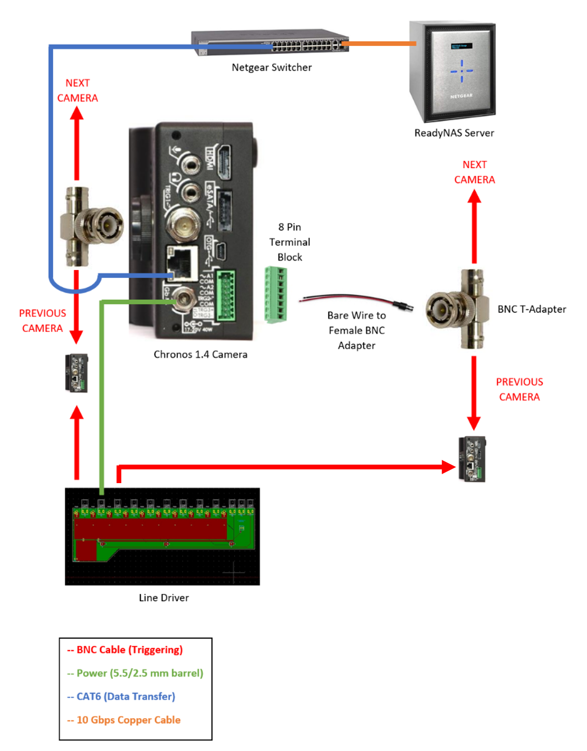

**Figure 4.2.** Connection method diagram for camera triggering and data transfer. The diagram has a legend in the bottom right corner for colored cable references. The Figure references the “Previous Camera” in two different locations. This is only for visualization sake, they are the SAME CAMERA.

### Using Ethernet Cable to Substitute Three Cables

There is another method of connection that will significantly reduce the cabling required to operate the array. We learned about this in our last meeting before our project was halted and did not have the time to properly research/test this option. Kron Tech has successfully done this with their own cameras, and they are willing to sell the technology to Dr. Mueller, should you decide to use it.

Rather than four cables (two BNC, power, and CAT5) to each camera, this method uses two CAT5 cables and Power-Over-Ethernet (POE). RJ45 connectors/Ethernet cables have eight cables running through them, arranged in four pairs. In this application, one ethernet cable would be connected to the data transfer port and would follow the same configuration outlined above. The other cable would be divided into three parts: Power, Trigger 1, and Trigger 2. The first pair of cables would be used for Power Positive (given the amperage required, a single cable would be unable to handle the load). The second pair of cables would be used for Power Negative. The third pair would be split, with one cable providing Trigger 1 positive and the other providing Trigger 1 negative. The fourth and final pair would also be split, with one cable providing Trigger 2 positive and the other providing Trigger 2 negative. This method requires the modification of the current line driver schematic to connect all three ports for each camera into one RJ45 connector. On the camera side, a board (already constructed by Kron Tech) would break the cable back out into power, Trigger 1, and Trigger 2.

Though this method requires more boards (one board for each camera and multiple line drivers), it cuts the total number of cables required in half. Modification of the arrangement of cameras or structure would be significantly simplified and CAT5 cable is significantly cheaper than BNC cable. It is recommended that this work is assisted by an Electrical Engineer or electrician. POE must be wired correctly, or the cameras could be seriously damaged (driving 40W into one of the Trigger ports, for example). Standard POE cable configuration should also be used to prevent any future additions to the system damaging equipment. For more information regarding this subject, contact Kron Technologies or Christian Mergl.

## Data Transfer and Storage Options - Christian/Wenkun

Data storage can be accomplished in two ways. The both methods require switchers, solid state drives (SSDs), and servers. The switcher configuration was recommended by Kron Technologies, as they are familiar with using it for their Cronos Ring. The server can be either purchased or built, depending on the skill of the team or available outside resources (Electrical and Computer Engineer, for example). Finally, the drive configuration will be determined by the server selected. Both methods have unique performance data that will be discussed below.

### Purchased Server ($3500)

The purchased server configuration will require all of the equipment listed in Table 7.3. This particular configuration uses two servers that are connected to the network, each downloading data simultaneously. The bottleneck in download speed for this configuration occurs at the SSDs in each server. Each SSD has a write speed of 500 MB/s. At optimal performance specifications, two servers downloading simultaneously will bring the write speed up to 1000 MB/s. With 800 GB of data recorded for each run, it will take 800 seconds (13 minutes, 20 seconds) for each data run to download to the server.

This configuration has the distinct advantage of being significantly easier to configure for the array. The server is prebuilt and requires no software installation or system configuration.

### Custom Built Server ($4000)

The custom built server will be much more difficult to construct, but will nearly triple the performance of data download speed. All necessary components of this build are listed in Table 7.4. It is important to note that, before any equipment is purchased, a thorough analysis of compatibility and newly available equipment should be performed.

The bottleneck in download speed for this configuration occurs at the SSD as well, but it is being used for a different purpose. The SSD in this configuration is operating as a “cache.” Data retrieved from the cameras is downloaded to this drive first and then distributed to the WD 16TB Attached Storage module. When data is collected from the cameras and downloaded to the SSD drive at maximum write speed, it can attain download at 2900 MB/s. This means that data download will only take 4 minutes and 39 seconds. Five trials can be run to fill the SSD before any additional transfer occurs. Once the SSD (or “cache”) is full, it can be transferred out to the WD 16 TB Attached Storage module. The write speed for the WD module however is only 108 MB/s, meaning it will take nearly 10 hours to download all 4 TB.

This configuration has the advantage of improved write speeds, but does not allow as many consecutive tests before data needs to slowly transfer to another location. If budget allows, increase the SSD size to increase cache before data needs to be transferred or change the WD Attached Storage drives to SSDs for increased long-term storage write performance.

## Data Transfer and Storage Topography - Christian

## 

**Figure 4.3.** A total of 50 Chronos 1.4 cameras are divided into groups of 12 or 13 and connected to a Mikrotek switch using Cat5e or Cat6 (1Gbps) cable. The Mikrotek switchers are then connected to the Ubiquiti switcher using SFP+ Fiber cable (10Gbps) cable. Then, depending on whether the server(s) are purchased or built, use 1 SFP+ cable to go to each purchased switcher or use 4 SFP+ cables to go to the quad port connection card.

## Monitors and Wiring - Jason

Moving forward, the array requires a system in place for the operators to monitor the interior of the tunnel. Although UNTESTED this was to be done by wiring a few camera feeds to exterior displays at a control console. The working ideas for this both use the feeds of five “Forward Angled” cameras of a given row as seen in Figure 4.4, but differ in wiring, display function, and cost. The option selected will largely be determined by the budget available when construction is continued. Our recommended solution, if budget allows, is detailed in *Section 4.5.3 - Display Solution 2A*, due to the added features and simultaneous cameras viewed. A breakdown of materials used in these solutions are available on the team’s Bill of Materials spreadsheet on Google Drive.

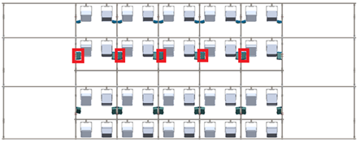

**Figure 4.4.** The cameras selected are boxed in red and are angled to the right of the tunnel, in this case the forward end of the tunnel. This method would allow the user to view the flight path of the animal sequentially as it navigates the tunnel.

### Display Solution 1A ($325)

The first of which was to use HDMI cables and directly connect the camera's HDMI output to the display's HDMI input. This method requires a monitor and HDMI cable per camera feed. This solution would cost roughly $325.

### Display Solution 1B ($169)

To cut down on cost the number of cameras can be reduced by implementing a 5x1 HDMI Switch. This device would take five HDMI inputs and feed them into a single monitor. Using the remote paired with the input selector, the operator would be able to switch between each feed to track the subject. The use of the 5x1 HDMI Switch reduces the cost to $169, but does not allow for the simultaneous viewing of the camera feeds.

### Display Solution 2A ($1,072)

If the budget allows, a multi-feed display on a single monitor can be made using the same five camera feeds by adding one HDMI to SDI converter per camera, a monitor and an SDI combiner with at least five input ports. For each camera the wiring chain will be Camera HDMI output > HDMI to SDI converter > Combiner. This chain of parts will require one HDMI and SDI cable per line to make the connections. Completing the chain will be a single HDMI cable from the output of the combiner to the display. This will allow for a display with multiple camera feeds as seen in Figure 4.5. This configuration is estimated to cost $1,072.

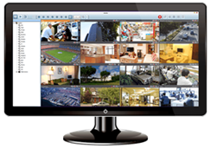

**Figure 4.5.** Example of Multi-feed display possible with a combiner setup. This example is using a 16 channel combine which allows for the 16 subsections. With a 4 channel combine there would be 4 feeds, but they would be substantially larger.

### Display Solution 2B ($580)

To reduce cost the number of camera feeds can be reduced from five to four as combiners are significantly more expensive with increased input ports. This would also reduce the wiring and converter count by one further reducing the cost. The resulting price is $580.

## Light Configuration and Wiring - Christian/Armani

The wiring method for the Nila Boxer lights is very straightforward. Each light requires 200W of power at full brightness. Given United States power standards, no more than nine lights should be run on a single circuit. The lights are configured in groups of eight, so it is recommended that only eight lights are connected to a single circuit. Therefore, a total of five independent circuits will be required to run all 40 lights in the array. Be sure to contact Dr. Mueller or a contact (Dr. Wahyu Caesarendra) in Brunei to get more information regarding the power configuration or limitations in Brunei. Also, check the Nila Boxer User Guide for more information on the specifications on the light fixture.

For controlling the lights, refer to the Nila Boxer User Guide for exact setup steps. A single DMX universe can be used to control all of the lights. A computer program that has lighting control paired with a USB to DMX converter should be able to run control. A crucial component of this configuration is the DMX to RJ45 adapter, which is available on the Nila website. Though there is documentation to wire this connector yourself, it is supposedly incorrect on the website. It is heavily recommended you simply purchase this adapter. Give each light an address (as specified in the User Manual) and then connect them together using a standard CAT5 cable. All of the lights should be able to be linked together and run on a single computer connection, as shown in Figure 4.6. This is also UNTESTED. Christian Mergl has extensive experience in DMX protocol and connections. Should any problems arise, contact him for more information. If this method is successful, all of the lights can be controlled in a group or individually.

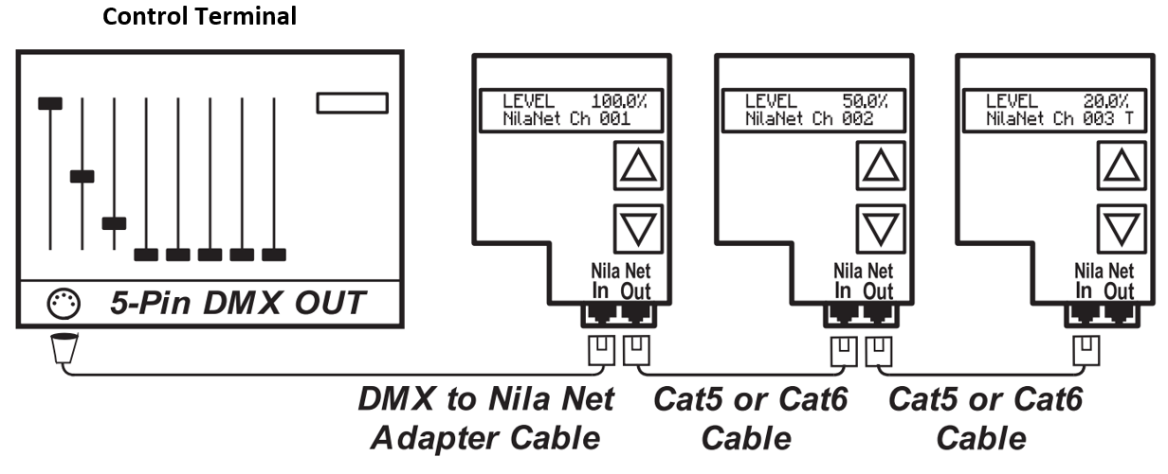

**Figure 4.6.** Standard DMX Control for Light Fixtures in Series. The configuration uses a control terminal to control all the lights and each light is connected by a Cat5 or Cat6 cable except for the control terminal. Notice that each light has a different brightness “LEVEL” indicated. This is because the control terminal will allow lights to be controlled independently.

Another way of controlling all the lights is to use the “Master Mode”, this helps with controlling all the lights by adjusting one light. To do so, connect all the lights with a Cat5 or Cat6 cable as seen in Figure 4.7. Choose one light to be the master control and hold the “Up” button on the master light until “Nila Master Mode” is seen on the screen on the light. Then on the rest of the lights, press the “Down” button until “NilaNet” shows up on the interface. Make sure that all lights that are going to be controlled are in the same channel as seen in Figure 5.6.

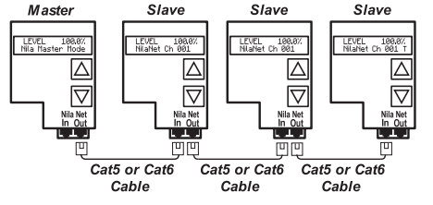

**Figure 4.7.** “Master Mode” configuration, where one light fixture controls all the lights’ brightnesses. Simply connect a Cat5 or Cat6 cable, so all the lights can communicate with each other. Notice that all lights share the same brightness “LEVEL” and cannot be controlled independently.

## Cable Management - Anuj/Spencer

In order to make sure that all of the cables in the tunnel design are contained, our team planned to use wire looms and zip ties. The looms have the ability to encase multiple wires together from the cameras and lights and attach them along the structure. Running these cables inside of looms can reduce the tripping hazards, protect the cables, and make the cables more accessible should they need to be replaced. For reference, an example of a loom over wire is shown in Figure 4.8. The team will have to base their loom sizing on which method they choose to power their cameras, detailed in *Section 4.2 - Methods for Data Transfer and Triggering.* Using the BNC cable method requires four cables to be run from each camera, however the Power over Ethernet (PoE) method requires half the cabling and thus, would require thinner looms. A table of two loom options has been compiled below in Table 4.1 and purchase links are available on the team’s Google Drive. Once cables have been wrapped into looms, the looms can be zip tied to the structure to ensure they follow the desired path around the array. Depending on what wiring configurations are chosen, the best way to wrap the cables around the array may change. A proposed routing pattern for the loom is shown in Figure 4.9.

It is important to note that lighting control protocol (Nila-Net) may experience interference and light flicker if the cables are not properly shielded. For additional separation, the lighting cables and camera cables can be run in different looms. Alternatively, using shielded Cat5e, Cat6, or Cat7 should provide proper isolation.

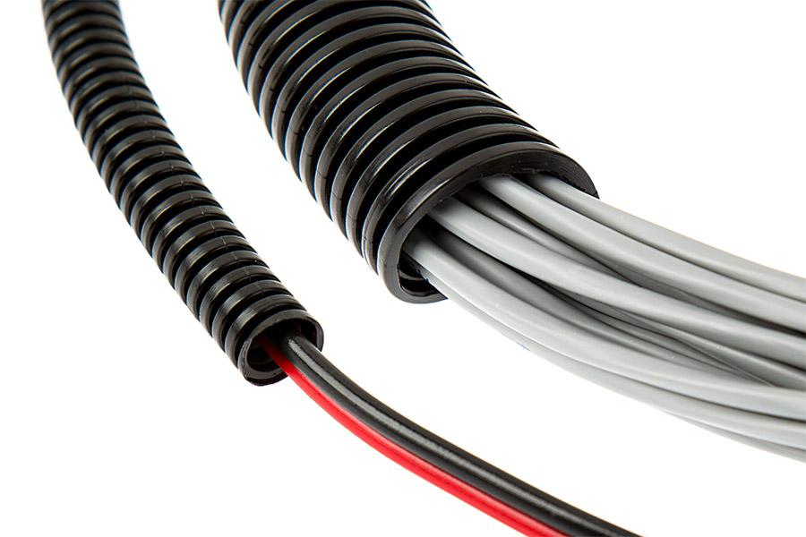

**Figure 4.8.** An example of using looms over wire in order to contain the wires for cable management. The looms can make sure that multiple wires are all in one contained area.

**Table 4.1: Loom Pricing Options**

| **Item Description** | **Location** | **Part Number** | **Quantity** | **Cost Per Unit** | **Total Cost** |
| --- | --- | --- | --- | --- | --- |
| 1/2" Diameter - 250' Wire Loom | Cable Ties and More | WL903-BK-250 | 2 | $21.21 | $42.42 |
| 3/4" Diameter - 250' Wire Loom | Cable Ties and More | WL904-BK-250 | 2 | $41.00 | $82.00 |

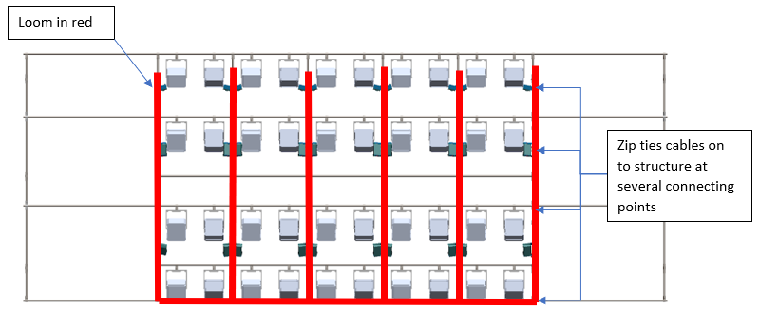

**Figure 4.9.** Side view of the tunnel showing proposed loom placements highlighted in red. The looms can be run down the structure and zip tied to secure them. Precise routing of the cabling is unknown at this time due to how the team chooses to power the array and the amount of cabling required.

# Control Terminal - Christian

The control terminal needs to be built using a Linux operating system. If no one on the team is familiar with Linux, it is recommended that you seek help from a Computer Science or Computer Engineering student at Virginia Tech. The control terminal will pose four major functions: arming cameras for recording, triggering data collection, stopping data collection if needed, and managing the transfer of data from the cameras to the servers.

The Chronos 1.4 High-Speed Cameras use a Linux operating system that can be accessed through the ethernet connection for data transfer. This function was used to develop the Chronos Ring Control Terminal used by Kron Technologies, seen in Figure 5.1. This is UNTESTED by our team. Our team was unable to use this feature, as we did not yet have the software update we needed. You will have access to the updated cameras, and it is recommended that you contact Kron Technologies at your earliest convenience to begin building your control interface.

Additionally, if you decide to use a DMX controller for lighting, another program on the computer could run lighting control. With this added system component, all lights and cameras could be controlled from a single control terminal.

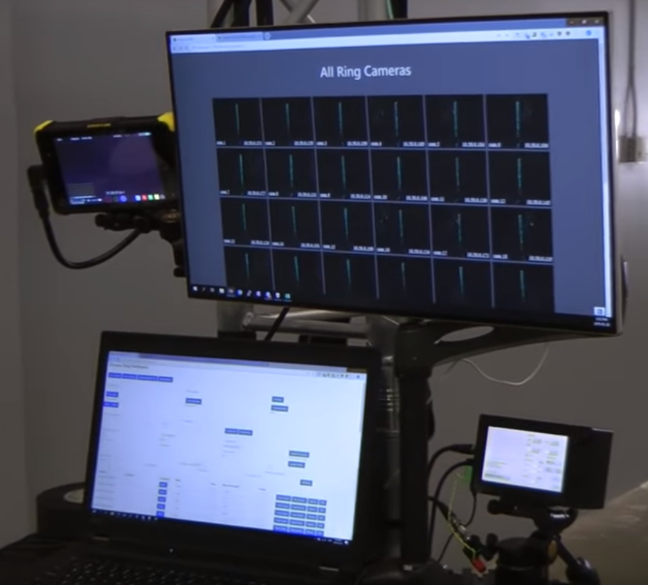

**Figure 5.1.** Chronos Ring Control Terminal displaying multiple feeds on a single monitor. The bottom screen is used to control camera triggering and initiate recording, the top monitor uses multiple camera feeds to give the operator visual feedback from the array.

# Test and Operation - Christian

The array will be tested in five stages: light testing, camera trigger testing, data transfer testing, a full test run, and finally the 3D reconstruction testing. In that order, each component of the array can be tested individually, together, and then against the tracking program.

## Light Testing

Ensure lights are connected to power with no more than eight lights per circuit. Ensure all cables connecting lights for control are securely connected and no power or data wires are damaged.

CAUTION: Using multiple lights will be extremely bright. For the safety of all persons around the array, use verbal warnings and receive confirmation from all people present before turning on any lights. Given the number of lights used, there is the possibility of eye damage due to the intensity of the light, do not look directly into any light. This test is purely to demonstrate the capability of the control program.

Turn on every light. Make sure that all lights are configured using the manufacturer's recommended settings (for DMX control or Master-Slave). Using the chosen control method, cycle the lights through 0-100% brightness, OR THE BRIGHTEST SAFE INTENSITY, slowly.

If any lights are not changing brightness properly, check cable connections and system configuration before proceeding. If multiple lights are operational and there is a point in the array where all following lights are not working, replace the data cable before the non-functional light. The cable or connection may be bad.

## Camera Trigger Testing

Ensure all cables are connected securely to the cameras, boards, power supplies, control terminal, and server(s). Ensure no cables are frayed or otherwise damaged.

Turn on the control terminal. Turn on all line drivers and then all cameras. Turn on the switchers and server(s). After all equipment is on, make sure that all cameras are configured properly (refer to II.E for more information). Using the control terminal, arm all cameras for recording.

Begin recording a single trial run and have all available persons monitoring the camera’s performance. This trial is not to check the camera’s video capture, it is solely to ensure that the control terminal is triggering cameras properly. Should any cameras not arm or record properly, check all cable connections to that camera. If all cameras are operating as expected, move on to the data transfer testing.

## Data Transfer Testing

Once data has been collected for a single trial test, initiate a data transfer from the control terminal. This test should be timed. The time will be important to providing proper documentation to any future users. Once all data is stored on a server, ensure that it can be accessed by another computer (as data reconstruction will be done on another device).

If data can be accessed by another computer, delete the stored data. Ultimately, data will need to be cleared from the server for future tests and this test will ensure that is possible. When the server is completely clear, you can move on to the full test run.

## Full Test Run

This test will use the lights, control terminal triggering, and data transfer tests together. It is important that this test is done as fluidly as possible. Breaks in this test will produce inaccurate timing results. This section is broken into steps for easier reading during testing. Ensure that all equipment is powered down before beginning this process.

As a recommended template for timing information, Table 6.1 can be used. Note that for each step that timing is recommended, a note, “**T.R.:**” will be placed at the beginning of the step.

**Table 6.1: Full Test Timing Results**

| Step Number / Name | Time Taken for Step (sec) |
| --- | --- |
| 1. Power Up All Equipment |  |
| 3. Time Trial Data Collection |  |
| 4. Time Data Transfer |  |

1. **T.R.:** Power up all equipment safely. Start at the beginning of each data line and work forward
   1. First, power up the control terminal
   2. Second, power up the line drivers and lights
   3. Third, power up the cameras
2. Test light control to ensure lights are operating properly and set them to a comfortable brightness for someone to be in the tunnel.
3. **T.R.:** With someone positioned at one end of the tunnel, begin a trial run with them walking through the tunnel at a comfortable pace, flapping the cardboard bat wing. The average person walks at 1.4 meters per second so they should reach the end of the tunnel in < 8 seconds. Time this step and the next step without stopping the timer.
4. **T.R.:** Initiate data transfer to server storage. Once data transfer is complete, stop timer.

## Point Tracking Testing

Using the data collected from the above trial, run the point tracking software to reconstruct points on the bat wing in 3D space. This step is UNTESTED with more than two cameras, as the cameras must all be calibrated before reconstruction can occur. Our graduate research assistant Xiaoyan Yin has more knowledge of the tracking program and may be able to assist with more than two camera reconstruction.

# Budget and Ordering

## Previously Purchased - Spencer

The team was able to purchase a portion of the necessary structural materials before the project was shut down. Materials purchased included: steel tubing, connectors, canvas material for the inside of the tunnel, rubber sheets for cushioning underneath the structure, and tools to facilitate assembly. A complete list of materials purchased by the team can be found in Table 7.1, along with their respective price, quantity, and purchase location. This table with working website links can be found on the team’s Google Drive in the Bill of Materials spreadsheet.

**Table 7.1: Purchased Materials**

| **Category** | **Item Description** | **Location** | **Part Number** | **Qty** | **Cost Per Unit** | **Total Cost** |
| --- | --- | --- | --- | --- | --- | --- |
| *Preliminary*  *Testing and*  *Prototyping* | Ambient Temperature Sensor | Amazon | N/A | 2 | $19.99 | $39.98 |
| White Silk Diffusion Fabric (60" x 36") | Amazon | N/A | 1 | $7.45 | $7.45 |
| Litepanel Translucent Fabric (39" x 39") | Amazon | N/A | 1 | $36.98 | $36.98 |
| Nylon Diffusion Fabric (72" x 60") | Amazon | N/A | 1 | $14.49 | $14.49 |
| PVC Parts and Cement | Lowe's | N/A | N/A | N/A | $54.78 |
| Low Carbon Steel Round Tube - 1" OD | McMaster | 7767T371 | 10 | $20.51 | $205.10 |
| Adjustable-Angle Wye | McMaster | 2534T33 | 24 | $6.40 | $153.60 |
| Rail End | McMaster | 2534T82 | 6 | $8.60 | $51.60 |
| *Structural* | 8' Steel Rails - 1" OD  0.065" Wall Thickness | McMaster | 2534T2 | 53 | $17.00 | $901.00 |
| Closed Tee | McMaster | 2534T21 | 58 | $3.24 | $187.92 |
| Three-Way 90 deg. Elbow | McMaster | 2534T24 | 22 | $5.84 | $128.48 |
| Five-Way Cross | McMaster | 2534T26 | 28 | $8.40 | $235.20 |
| Crossover | McMaster | 2534T28 | 6 | $3.34 | $20.04 |
| Rail Support | McMaster | 2534T31 | 14 | $4.50 | $63.00 |
| 45 deg. Wye | McMaster | 2534T84 | 24 | $5.14 | $123.36 |
| Four-way Cross | McMaster | 2534T25 | 12 | $5.12 | $61.44 |
| Six-Way Cross | McMaster | 2534T27 | 12 | $11.68 | $140.16 |
| 4' x 15' 8mm-Thick  Rubber Sheet - Black | Rubber Flooring Inc. | N/A | 3 | $189.46 | $568.38 |
| Cotton Polyester Broadcloth (36' x 44/45") - White | Fabric Wholesale  Direct | N/A | 12 | $1.99 | $29.67 |
| *Miscellaneous* | Wood Template Supplies | Lowe's | N/A | N/A | N/A | $112.65 |
| Tools/PPE | Various | N/A | N/A | N/A | $1,049.20 |
| Lab Safety Masks/Organization | Harbor Freight | N/A | N/A | N/A | $122.07 |
| **Grand Total:** | | | | | | **$4,306.55** |

## Future Purchasing

A table of future purchases is displayed in Table 7.2 with similar details. It should be noted that the electrical components listed in this table were researched, but remain UNTESTED. Again, working website links at the time of this writing are available on the team’s Bill of Materials spreadsheet on the Google Drive. The team designed three different camera mounts to support the cameras within the structure. Quotes from March placed the total cost of all required mounts around $3,700 with included hardware, but seeking a new quote is recommended as prices and shipping times may have changed.

**Table 7.2: Materials to Purchase**

| **Category** | **Item Description** | **Location** | **Part Number** | **Qty** | **Cost Per Unit** | **Total Cost** |
| --- | --- | --- | --- | --- | --- | --- |
| *Structural* | 8' Steel Rails - 1" OD  0.065" Wall Thickness | McMaster | 2534T2 | 115 | $17.00 | $1,955.00 |
| Closed Tee | McMaster | 2534T21 | 58 | $3.24 | $187.92 |
| Three-Way 90 deg. Elbow | McMaster | 2534T24 | 22 | $5.84 | $128.48 |
| Five-Way Cross | McMaster | 2534T26 | 40 | $8.40 | $336.00 |
| Crossover | McMaster | 2534T28 | 6 | $3.34 | $20.04 |
| 45 deg. Wye | McMaster | 2534T84 | 24 | $5.14 | $123.36 |
| Four-way Cross | McMaster | 2534T25 | 20 | $5.12 | $102.40 |
| Six-Way Cross | McMaster | 2534T27 | 16 | $11.68 | $186.88 |
| 4' x 15' 8mm-Thick  Rubber Sheet - Black | Rubber Flooring Inc. | N/A | 3 | $189.46 | $568.38 |
| *Electrical* | 8 - Pin Terminal Block | Allied Electronics | 1757077 | 50 | $6.81 | $340.50 |
| Female BNC to Bare Wire | Products for Automation | BU-5200-A-4-0 | 50 | $6.04 | $302.00 |
| BNC T-Connector | Cable Wholesale | 31X1-05600 | 40 | $1.53 | $61.20 |
| 10' BNC Cable | Cable Wholesale | 10X1-01110 | 80 | $5.20 | $416.00 |
| 25' BNC Cable | Cable Wholesale | 10X1-01125 | 20 | $8.96 | $179.20 |
| 75' Cat6 | Cable Wholesale | 10X8-02275 | 10 | $14.43 | $144.30 |
| 50' Cat6 | Cable Wholesale | 10X8-02250 | 20 | $10.10 | $202.00 |
| 35' Cat6 | Cable Wholesale | 10X8-02235 | 20 | $7.25 | $145.00 |
| 6' Cat6 | Cable Wholesale | 10X8-02206 | 50 | $1.85 | $92.50 |
| Nila DMX Adapter Cable | Nila Outlet | N/A | 1 | $37.00 | $37.00 |
| ENTTEC Open USB-DMX Adapter | ENTTEC | 70303 | 1 | $70.00 | $70.00 |
| *Camera Mounts* | Configurations & Hardware | ProtoLabs |  |  |  | $3,741.67 |
| *Shipping* | Allison Shipping Inc. | N/A | N/A | N/A | N/A | $4,500.00 |
| **Grand Total:** | | | | | | **$13,839.83** |

## 

## End Section Materials

**Table 7.3: Proposed End Section Materials**

| **Item** | **Description** | **Location** | **Unit Price** | **Qty** | **Line Cost** |
| --- | --- | --- | --- | --- | --- |
| Mosquito Netting | Black Heavy Duty 12*24ft | Mosquito Net USA | $112.00 | 2 | $224.00 |
| Velcro (Hook) | Iron On Backing Hook | Hook and Loop | $87.50 | 3 | $262.50 |
| Velcro (Loop) | Iron On Backing Loop | Hook and Loop | $87.50 | 3 | $262.50 |
| Magnetic Door | Black 70" * 80" Doorway | Amazon | $28.99 | 2 | $57.98 |
| Grommet Kit | Grommets for fabrics | McMaster | Varies | Varies | Varies |
| Monofilament | Plastic line for attaching canvas | McMaster | Varies | Varies | Varies |
| Paracord | Chord for attaching canvas | Amazon | Varies | Varies | Varies |

## 

## Data Transfer and Storage Equipment - Christian/Wenkun

For further explanation of both Tables 7.4 and 7.5, refer to *Section 4.3 - Data Transfer and Storage Options.*

**Table 7.4: Purchased Server Bill of Materials**

| **Description** | **Quantity** | **Unit Cost** | **Line Total** |
| --- | --- | --- | --- |
| QNAP Server | 2 | $556.09 | $1,112.18 |
| 10 Gigabit PCIe Network Adapter | 2 | $119.99 | $239.98 |
| WD Blue 3D NAND 4TB SSD | 2 | $489.99 | $979.98 |
| Mikrotik Switcher | 4 | $142.60 | $570.40 |
| Ubiquiti Switcher | 1 | $599.00 | $599.00 |
| **Total:** | | | **$3,501.54** |

**Table 7.5: Custom Built Server Bill of Materials**

| **Description** | **Quantity** | **Unit Cost** | **Line Total** |
| --- | --- | --- | --- |
| 3U MATX Case | 1 | $105.99 | $105.99 |
| MATX Motherboard | 1 | $206.99 | $206.99 |
| Intel E2234 Processor | 1 | $273.99 | $273.99 |
| 4TB M.2 SSD | 1 | $849.99 | $849.99 |
| Noblik 10Gb NIC Quad Port | 1 | $251.60 | $251.60 |
| 16 ECC RAM | 1 | $94.99 | $94.99 |
| CoolMax 1000 W | 1 | $108.46 | $108.46 |
| Seagate IronWolf 8TB (240MB/s) | 4 | $222.99 | $891.96 |
| Mikrotik Switcher | 4 | $142.60 | $570.40 |
| Ubiquiti Switcher | 1 | $599.00 | $599.00 |
| **Total:** | | | **$3,953.37** |

## 

## Video Feed Display

Table 7.6 displays four separate itemized lists of our possible solutions for video feed display. As stated previously, the electrical components show in this table were researched, but remain UNTESTED. Website links for these items are available on the team’s Bill of Materials spreadsheet on Google Drive. Due to the size of the array’s rings where the cables are planned to be run it is recommended that the HDMI and SDI cables remain at least 25ft and 10ft respectively. See Section 4.5. For information on materials selection in Table 7.6.

**Table 7.6: Display Solutions for Array Video Output**

| **Category** | **Item Description** | **Location** | **Quantity** | **Cost Per Unit** | **Total Cost** |
| --- | --- | --- | --- | --- | --- |
| *Display Solution 1A* | Preliminary Monitor | Amazon | 5 | $50.00 | $250.00 |
| HDMI Cable 25ft | Amazon | 5 | $14.99 | $74.95 |
| ***Sub total*** | | | | | $324.95 |
| *Display Solution 1B* | 5x1 HDMI Switcher | Amazon | 1 | $28.99 | $28.99 |
| Preliminary Monitor | Amazon | 1 | $50.00 | $50.00 |
| HDMI Cable 25ft | Amazon | 6 | $14.99 | $89.94 |
| ***Sub total*** | | | | | $168.93 |
| *Display Solution 2A* | Preliminary Monitor | Amazon | 1 | $50.00 | $50.00 |
| HDMI Cable 25ft | Amazon | 5 | $14.99 | $74.95 |
| SDI Cable 10ft | Amazon | 4 | $12.25 | $49.00 |
| HDMI to SDI Converter | Amazon | 4 | $55.00 | $220.00 |
| 4 Channel Combiner | B&H Photo Video | 1 | $185.00 | $185.00 |
| ***Sub total*** | | | | | $578.95 |
| *Display Solution 2A* | Preliminary Monitor | Amazon | 1 | $50.00 | $50.00 |
| HDMI Cable 25ft | Amazon | 6 | $14.99 | $89.94 |
| SDI Cable 10ft | Amazon | 5 | $12.25 | $61.25 |
| HDMI to SDI Converter | Amazon | 5 | $55.00 | $275.00 |
| 6 Channel Combine | B&H Photo Video | 1 | $595.00 | $595.00 |
| ***Sub total*** | | | | | $1,071.19 |

## Brunei Shipping Quotes

Since the complete and tested array will be sent to the University of Brunei, overseas shipping of all materials was of importance as well. After much research, it was decided that a standard 20’ cargo crate shipped via ocean cargo would allow for the best value and ease for the team. Multiple companies were contacted and shipping times and costs varied. One teammate had extensive talks with Allison Shipping and they became our preferred choice for shipping when the time came. Quotes from March are available for viewing in Appendix A and on the team’s Google Drive, but a new quote should be obtained near the time of shipment to ensure accurate information. The estimated cost of shipping is included in the future purchases as well. The team has only considered what was deemed essential to the project at the time of shutdown, and has budgeted in about $2,500 for future purchases related to testing and other unforeseen expenses.

# Appendices

## Brunei Shipping Quotes

### Allison Shipping International Inc. Quote



### A2 Global Shipping Quote



## Chronos Ring Topography

### Chronos Ring Topography Map

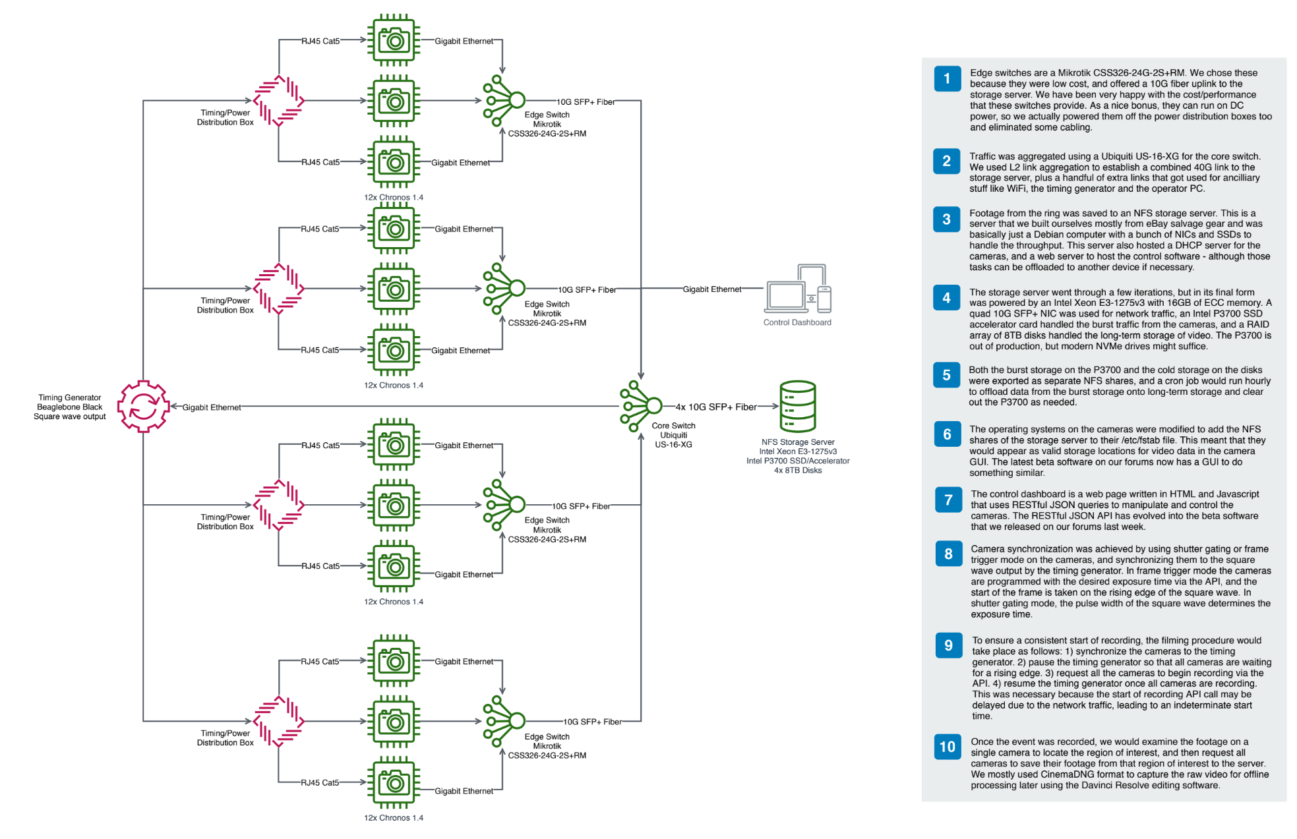

### Chronos Ring Topography Description

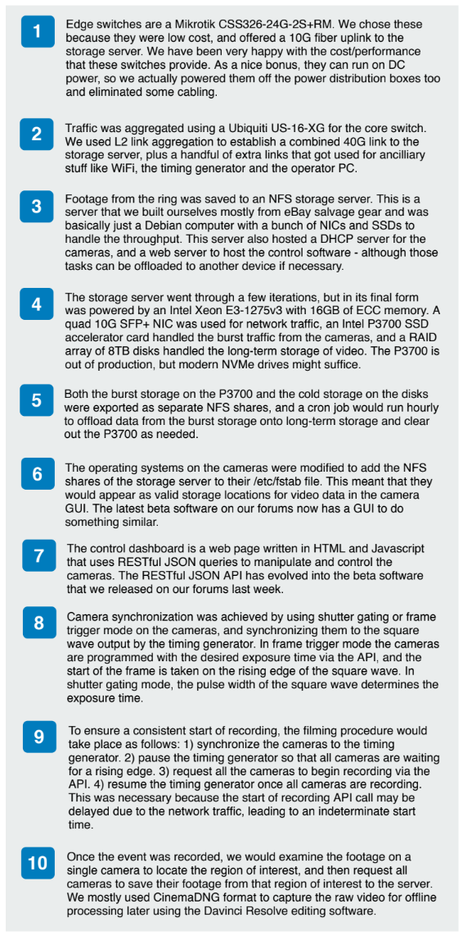

# Contact Information

* Dr. Rolf Mueller, Faculty Advisor - [rolf.mueller@vt.edu](mailto:rolf.mueller@vt.edu)
* Xiaoyan Yin, Graduate Research Assistant - [xiaoyan6@vt.edu](mailto:xiaoyan6@vt.edu)
* Dr. Wahyu Caesarendra, Professor at University of Brunei - [w.caesarendra@gmail.com](mailto:w.caesarendra@gmail.com)
* Previous Team Members:
  + Christian Mergl - [cmergs15@vt.edu](mailto:cmergs15@vt.edu)
  + Wenkun Liu - [wenkun9@vt.edu](mailto:wenkun9@vt.edu)
  + Alec Macarro - [alec9mm@vt.edu](mailto:alec9mm@vt.edu)
  + Spencer Kirkham - [skirk20@vt.edu](mailto:skirk20@vt.edu)
  + Armani Tagle - [armani1@vt.edu](mailto:armani1@vt.edu)
  + Jason Brannick - [jasonb1@vt.edu](mailto:jasonb1@vt.edu)
  + Anuj Roy - [roya1@vt.edu](mailto:roya1@vt.edu)
  + Kevin Byrnes - [kevinb1@vt.edu](mailto:kevinb1@vt.edu)